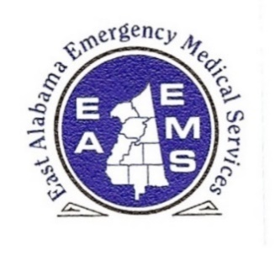
EAST ALABAMA
EMERGENCY MEDICAL SERVICES, INC.

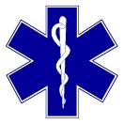
This is to Certify That
___________________
Has completed the course in
_________alabama EMS Protocol education_________
COURSE #_2022-R2-XXX__(_6.0_ CEU hours)
In witness whereof the seal of the agency and the signatures of the duly authorized
officers are hereunto affixed on this ___ day of _______.

Chief Executive Officer Service Medical Director

Course Instructor

