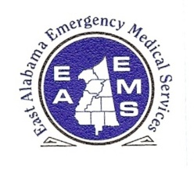

**EAST ALABAMA EMS**

Presents

*Pediatric Emergencies*

**FRIDAY, July 21, 2017**

**10:00 AM – 3:00 PM (CST)**

**Northeast Alabama**

**Regional Medical Center**

**1st Floor Private Dining Room**

**400 E 10th ST**

**Anniston, AL 36207**

**Sponsored by:**

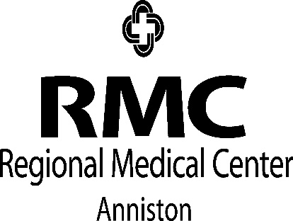

**OBJECTIVES**

* **Review important aspects of the pediatric patient**
* **Discuss common pediatric emergencies and treatments**
* **Review care of special needs patients**
* **Review sports injuries and early intervention**
* **Importance of early interventions and treatments by EMS and ER personnel**

**It’s a Free Class**

**Nurses and EMTs earn hours**

**Lunch will be provided.**

**Please pre-register, space is limited.**

There is no charge for attendance but pre-registration is strongly encouraged. 5.0 contact hours will be awarded to those who complete this program. No partial credit will be awarded. You must attend the course in its entirety to receive credit. EAEMS will be providing continuing education credits to EMT’s and nursing contact hours to nurses. East Alabama EMS is an approved provider of continuing education for nurses by the Alabama Board of Nursing. Provider Number ABNP 1456 expires: 08.25.2019. Nurses must bring their current Alabama Board of Nursing license to the program to be scanned in order to receive contact hours.

**TO REGISTER OR FOR MORE INFORMATION:**

**Contact East Alabama EMS 205.763.8400 or** [**eaems@centurytel.net**](mailto:eaems@centurytel.net)

