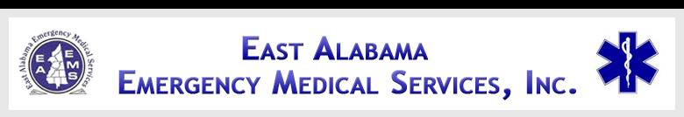

EAST ALABAMA EMS
Presents
NEUROLOGICAL INJURIES
At our 2ND FRIDAY LECTURE SERIES
FRIDAY, December 13, 2013
10:30 AM – 2:30 PM
RMC-Anniston
1st Floor Private Dining Room
400 E 10th ST
Anniston, AL 36207

Sponsored by

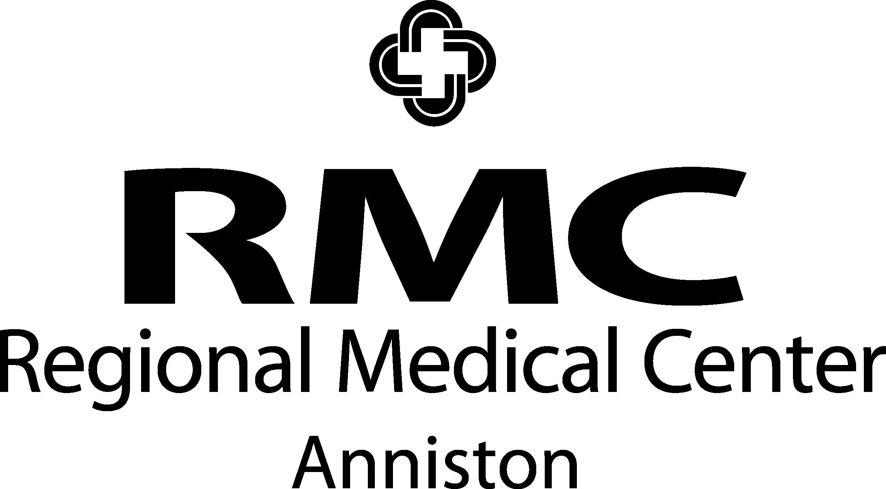

eastalabamaems.com
OBJECTIVES
During the course, the participant will:
- Review the anatomy and function of the neurological system;
- Be able to identify signs & symptoms of neurological injuries;
- Have an overview of different treatment modalities for neurological injuries;
- Understand the importance of early diagnostics and interventions for neurological conditions;
- Understand the roles the pre-hospital and in-hospital providers play in early interventions.
AGENDA

1030-1035 Introductions
1035-1105 Anatomy Review
1105-1135 Neurological Injuries
1135-1205 Lunch will be served
1205-1255 Seizures/Closed Head Injury
1255-1345 Subdural/Epidural
Hematomas; Axonal Injury
1345-1425 Treatments Modalities
1425-1430 Evaluations

SPEAKER INFORMATION

Tim Pesnell, BSN

Mr. Pesnell is a Registered Nurse working in the Emergency Department at Gadsden Regional Medical Center. He is also a Nationally Registered Paramedic and flight nurse with Lifesaver/Omniflight. He has over 30 years of experience in the field of emergency medicine.

There is no charge for attendance but pre-registration is strongly encouraged. 4.0 contact hours will be awarded to those who complete this program. No partial credit will be awarded. You must attend the course in its entirety to receive credit. EAEMS will be providing continuing education credits to EMT’s and nursing contact hours to nurses. East Alabama EMS is an approved provider of continuing education for nurses by the Alabama Board of Nursing. Provider Number ABNP 1456 expires: 08.25.2015. Nurses must bring their current Alabama Board of Nursing license to the program to be swiped in order to receive contact hours.
TO REGISTER OR FOR MORE INFORMATION:
Contact East Alabama EMS 205.763.8400 or eaems@centurytel.net

