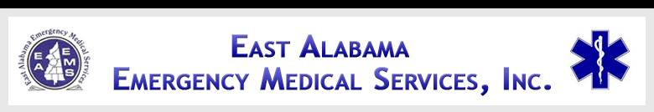

EAST ALABAMA EMS
Presents
STROKE CARE
At our 2ND FRIDAY LECTURE SERIES
FRIDAY, September 12, 2014
10:30 AM – 2:30 PM cst
Joe Ford Center Classroom
Gadsden State Community College
East Broad Campus
405 Korner St, Gadsden, AL 35903
Ctrl + click for Google Map
Sponsored by:
RIVERVIEW
Regional Medical Center

OBJECTIVES
- Review the anatomy of the neurological system;
- Identify early signs & symptoms of strokes;
- Discuss early diagnostics and interventions;
- Discuss different treatment modalities;
- Understand the roles the pre-hospital and in-hospital providers play in early interventions.

AGENDA

1030-1035 Introductions
1035-1105 Anatomy Review
1105-1135 Signs & Symptoms
1135-1205 Lunch will be served
1205-1255 Diagnostics & Interventions
1255-1345 Treatment Modalities
1345-1425 Early Interventions
1425-1430 Evaluations

SPEAKER INFORMATION

Michael J. Lyerly, M.D.

Dr. Lyerly is an Assistant Professor at UAB within the Department of Neurology in the Cerebrovascular Disease Division. Dr. Lyerly’s major research interests are examining barriers to acute stroke care, examining racial disparities in acute stroke care, and examining utilization of IV thrombolysis for acute stroke.

There is no charge for attendance but pre-registration is strongly encouraged. 4.0 contact hours will be awarded to those who complete this program. No partial credit will be awarded. You must attend the course in its entirety to receive credit. EAEMS will be providing continuing education credits to EMT’s and nursing contact hours to nurses. East Alabama EMS is an approved provider of continuing education for nurses by the Alabama Board of Nursing. Provider Number _ABNP 1456__ expires: _08.25.2015_. Nurses must bring their current Alabama Board of Nursing license to the program to be swiped in order to receive contact hours.
TO REGISTER OR FOR MORE INFORMATION:
Contact East Alabama EMS 205.763.8400 or eaems@centurytel.net

