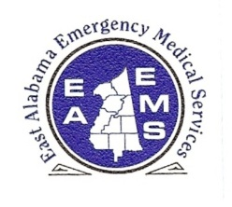
EAST ALABAMA EMS
Presents
MCI and NIMS

At our 2ND FRIDAY LECTURE SERIES
FRIDAY, April 12, 2013
10:30 AM – 2:30 PM (CST)
Gadsden State @ McClellan
256-238-8342
100 Gamecock Drive
McClellan, AL 36205
(aka Ft. McClellan in Anniston)
Classroom 2137
Map Link
(CTRL and click)

Sponsored by

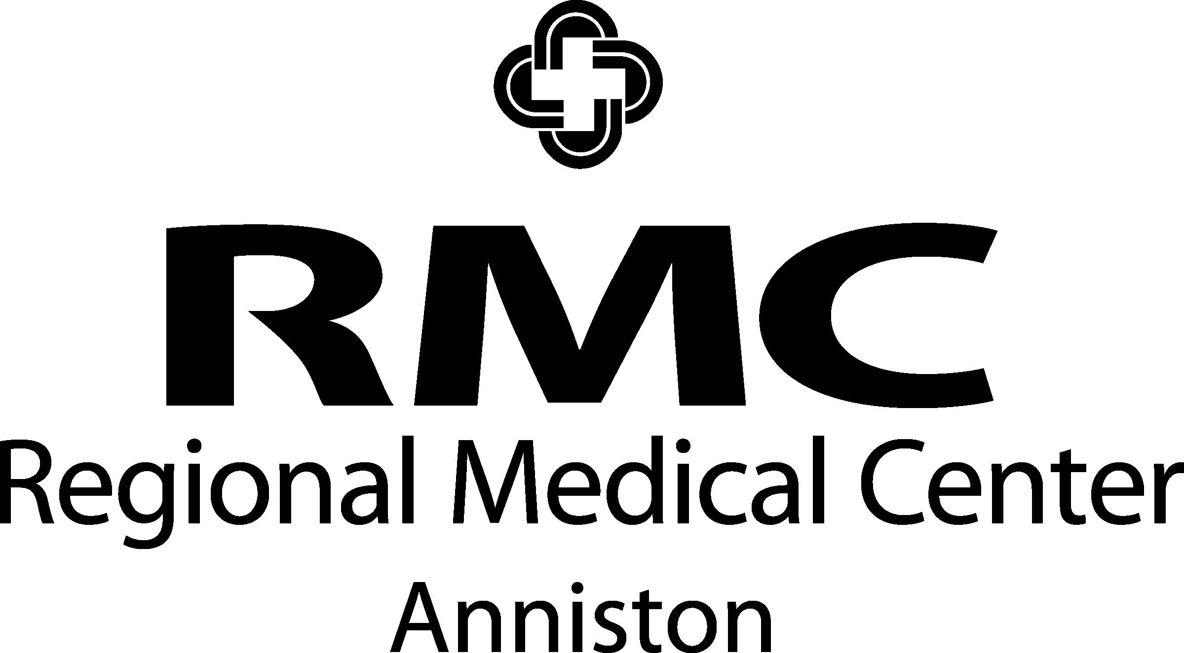

OBJECTIVES
During the course, the participant will:
- Review basic incident command procedures and protocols
- Learn about disaster response and agencies involved
- Review mass casualty triage protocols, procedures, and equipment
- Participate in a scenario utilizing NIMS and MCI triage information

AGENDA

1030-1035 Introductions
1035-1115 Review of NIMS
1115-1200 Review MCI triage
1200-1230 Lunch (will be served)
1230-1345 Incident Scenario
1345-1425 Debriefing of scenario
1425-1430 Evaluations

PRE-REGISTER BY
WEDNESDAY-- APRIL 10

SPEAKER INFORMATION

Blaine R. Ehrlich, EMS-P

Mr. Ehrlich is a critical care flight paramedic, certified with Alabama, Tennessee, & Florida and instructor in PALS, PHTLD, ITLS, & AMCC. He is also a member of Florida State FEMA Urban Search & Rescue Task Force 8 Team.

There is no charge for attendance but pre-registration is strongly encouraged. 4.0 contact hours will be awarded to those who complete this program. No partial credit will be awarded. You must attend the course in its entirety to receive credit. EAEMS will be providing continuing education credits to EMT’s and nursing contact hours to nurses. East Alabama EMS is an approved provider of continuing education for nurses by the Alabama Board of Nursing. Provider Number ABNP 1456 expires: 08.25.2015. Nurses must bring their current Alabama Board of Nursing license to the program to be scanned in order to receive contact hours.
TO REGISTER OR FOR MORE INFORMATION:
Contact East Alabama EMS 205.763.8400 or eaems@centurytel.net
