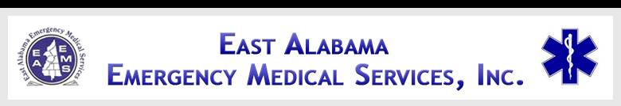

EAST ALABAMA EMS
Presents
CATH LAB
At our 2ND FRIDAY LECTURE SERIES

FRIDAY, December 14, 2012
10:30 AM – 2:30 PM
AT THE EAST ALABAMA EMS OFFICE
58 SPEEDWAY INDUSTRIAL DRIVE
LINCOLN, ALABAMA 35096
205.763.8400
eastalabamaems.com
Sponsored by


OBJECTIVES
During the course, the participant will:
- Review anatomy and physiology
- Discuss cath lab procedures
- Understand basics of ECG
- Review angiography and intervention
- Understand the roles the pre-hospital and in-hospital providers play in early interventions

AGENDA

1030-1035 Introductions
1035-1105 Anatomy Review
1105-1135 Medical Emergencies
1135-1205 Lunch will be served
1205-1255 ECG basics
1255-1345 Cath Lab procedures
1345-1425 Treatment Modalities
1425-1430 Evaluations

SPEAKER INFORMATION

Djiby Diop, M.D., M.S., M.P.H., FACEP

Dr. Diop is currently the Medical Director at Gadsden Regional Medical Center. He is a graduate of Brown University Medical School and Harvard School of Public Health. Dr. Diop is an experienced ER Physician who has spoken at numerous national and international conferences.

There is no charge for attendance but pre-registration is strongly encouraged. 4.0 contact hours will be awarded to those who complete this program. No partial credit will be awarded. You must attend the course in its entirety to receive credit. EAEMS will be providing continuing education credits to EMT’s and nursing contact hours to nurses. East Alabama EMS is an approved provider of continuing education for nurses by the Alabama Board of Nursing. Provider Number ABNP 1456 expires: 08.25.2015. Nurses must bring their current Alabama Board of Nursing license to the program to be scanned in order to receive contact hours.
TO REGISTER OR FOR MORE INFORMATION:
Contact East Alabama EMS 205.763.8400 or eaems@centurytel.net

