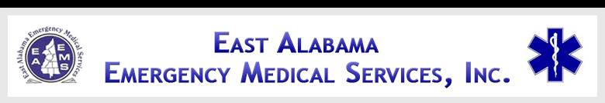

EAST ALABAMA EMS
Presents
Abdominal Emergencies
At our 2ND FRIDAY LECTURE SERIES

FRIDAY, November 9, 2012
10:30 AM – 2:30 PM
AT THE EAST ALABAMA EMS OFFICE
58 SPEEDWAY INDUSTRIAL DRIVE
LINCOLN, ALABAMA 35096
205.763.8400
eastalabamaems.com
Sponsored by


OBJECTIVES
During the course, the participant will:
- Review the anatomy and physiology of the gastrointestinal system;
- Discuss abdominal medical emergencies including signs, symptoms, etiologies, and treatments;
- Discuss abdominal traumatic injuries caused by blunt and penetrating trauma including signs, symptoms, etiologies, and treatments;

AGENDA
1030-1035 Introductions
1035-1125 Review of Anatomy
1125-1155 Lunch (will be served)
1155-1245 Medical Emergencies
1245-1335 Traumatic Emergencies
1335-1425 Role of early interventions of
pre-hospital and in-hospital
personnel
1425-1430 Evaluations

SPEAKER INFORMATION

Tim Pesnell, BSN

Mr. Pesnell is a Registered Nurse working in the Emergency Department at Gadsden Regional Medical Center. He is also a certified Paramedic and flight nurse with Lifesaver. He has over 30 years of experience in the field of emergency medicine.

There is no charge for attendance but pre-registration is strongly encouraged. 4.0 contact hours will be awarded to those who complete this program. No partial credit will be awarded. You must attend the course in its entirety to receive credit. EAEMS will be providing continuing education credits to EMT’s and nursing contact hours to nurses. East Alabama EMS is an approved provider of continuing education for nurses by the Alabama Board of Nursing. Provider Number ABNP 1456 expires: 08.25.2015. Nurses must bring their current Alabama Board of Nursing license to the program to be scanned in order to receive contact hours.
TO REGISTER OR FOR MORE INFORMATION:
Contact East Alabama EMS 205.763.8400 or eaems@centurytel.net

