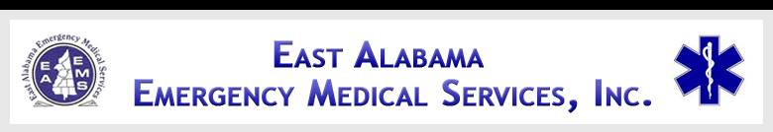

EAST ALABAMA EMS
Presents
AIRWAY ISSUES
At our 2ND FRIDAY LECTURE SERIES
(Moved to 3rd Friday due to Veterans Day)
FRIDAY, November 18, 2011
10:30 AM – 2:30 PM
AT THE EAST ALABAMA EMS OFFICE
58 SPEEDWAY INDUSTRIAL DRIVE
LINCOLN, ALABAMA 35096
205.763.8400
eastalabamaems.com
Sponsored by


AN AIRMETHODS COMPANY
OBJECTIVES
During the course, the participant will:
- Review the anatomy and physiology of the respiratory system and the airway;
- Discuss the importance of a patent airway;
- Discuss specific respiratory conditions that may contribute to airway inadequacy;
- Discuss the different devices which can be utilized to maintain a patent airway; and
- Discuss the various techniques for ventilating a patient

AGENDA
1030-1035 Introductions
1035-1100 Review of Anatomy of Airway
1100-1125 Importance of patent airway
1125-1155 Lunch (will be served)
1155-1220 Specific respiratory conditions
1220-1245 Devices to maintain patent airway
1245-1335 Techniques for ventilating a patient
1335-1425 Role of early interventions of
pre-hospital and in-hospital
personnel
1425-1430 Evaluations

SPEAKER INFORMATION

Don Wilson, EMT-P

Mr. Wilson is a Paramedic with the City of Gadsden Fire Department and a flight medic with LifeSaver Alabama and the manager at Altoona Emergency Medical Department ambulance. He has over 30 years of experience and is a Critical Care Paramedic. Mr. Wilson has also been an ACLS and ITLS instructor since 1982 specializing in intubation and instruction.

There is no charge for attendance but pre-registration is strongly encouraged. 4.0 contact hours will be awarded to those who complete this program. No partial credit will be awarded. You must attend the course in its entirety to receive credit. EAEMS will be providing continuing education credits to EMT’s and nursing contact hours to nurses. East Alabama EMS is an approved provider of continuing education for nurses by the Alabama Board of Nursing. Provider Number ABNP 1456 expires: 08.25.2015. Nurses must bring their current Alabama Board of Nursing license to the program to be scanned in order to receive contact hours.
TO REGISTER OR FOR MORE INFORMATION:
Contact East Alabama EMS 205.763.8400 or eaems@centurytel.net

