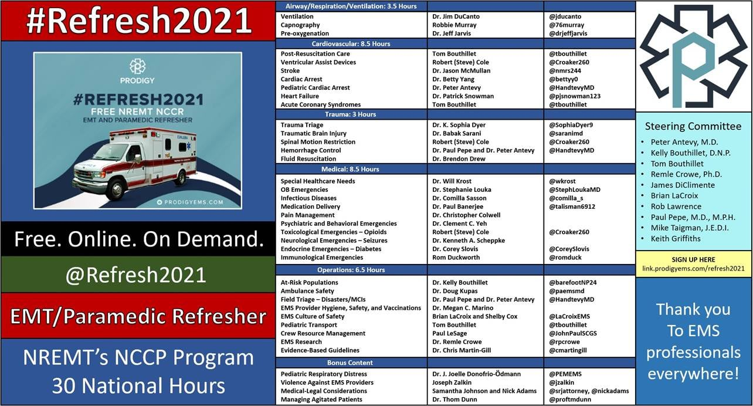
And it goes online Dec 15th.
Register here: https://link.prodigyems.com/refresh2021

