Plantation Pipe Line
- Who we are?
- In case of emergency
- Signs of a leak
- Survey
- Contact
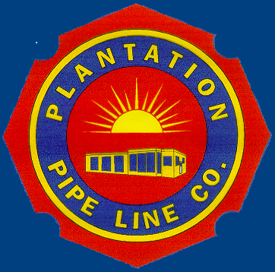
As we hope you know, Plantation is a liquid petroleum pipeline operator in several counties throughout Alabama. We've put together this internet resource specifically for you that contains helpful pipeline safety response information.

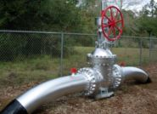

Library
Emergency Response Information
Map: Southeast Region

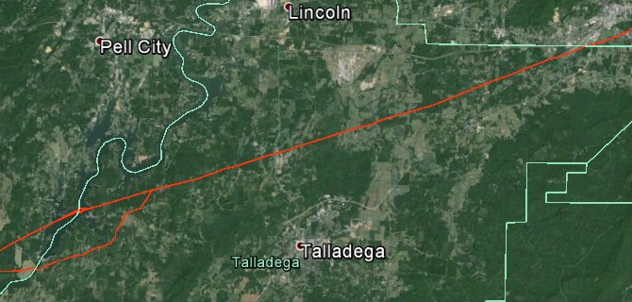

- 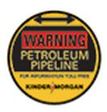

Local Contact
Steve Polk
Operations Manager
(770) 330-3691
steve_polk@kindermorgan.com

Mike Ford
Operations Supervisor
(601) 543-8932
mike_ford@kindermorgan.com

Who we are?
Plantation Pipeline Company (a Kinder Morgan Company) is one of the largest refined products pipelines in the United States. It delivers approximately 600,000 barrels per day of gasoline, jet fuel, diesel and biodiesel through its 3,100 mile pipeline network, which originates in Louisiana and ends in the Washington, D.C. area. Along the way it serves various metropolitan areas including Birmingham, Alabama; Atlanta, Georgia; Charlotte, North Carolina; and the DC area.
Working Together To Protect Pipelines
& Right-of-Ways
In addition to 24-hour monitoring and on-going safety and
security procedures, Kinder Morgan relies on you, the local
emergency responder, to notify Kinder Morgan when you
observe potential right-of-way restriction violations or
potential damage to our facilities, which could endanger
public safety. We support your enforcement of “Call Before
You Dig” requirements in states where they apply.
Excavation activity is the most common cause of serious
pipeline damage. In most states, residents, excavators
and farmers are required by law to call 811 or their local
One-Call center at least two or three working days before
starting an excavation project to have underground
utilities marked. Refer to your state-specific One-Call
laws for more information.
Additionally, some emergencies may require excavation
and/or use of heavy equipment that could damage
underground utilities. Call 811 to identify and notify
utilities in the area that may be impacted by these
emergency activities.
Unauthorized use, such as building or planting, in the
pipeline right-of-way is known as encroachment. Kinder
Morgan regularly conducts maintenance to trim trees and
remove shrubs or structures that prohibit the company
from clearly viewing the pipeline corridor during aerial
or foot patrols and regular maintenance activities.
Please contact us if you know of places where trees, plants
or structures are located on the pipeline right-of-way or if
you see individuals digging in areas where underground
utilities are not marked with flags.

Video

