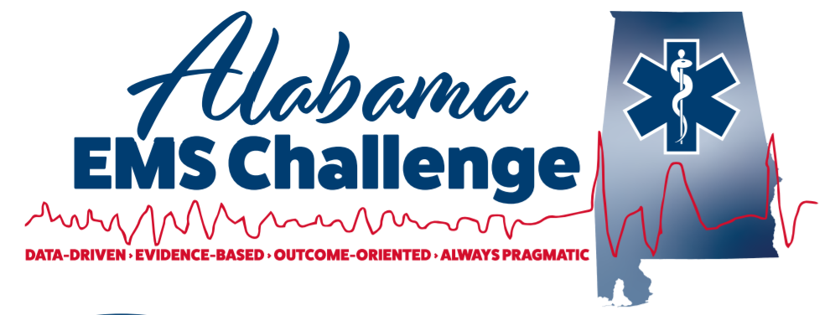March 8th , 2023, at 9am (0900-1100) at Fultondale Event Center, hosted by Fultondale Fire and Rescue. Fultondale Event Center, 2980 Hawkins Lane, Fultondale, AL 35068
Physician-Led Continuing Education for EMS Providers
This is a great opportunity for EMS providers, nurses, students, or anyone interested in emergency medicine.
Come in person or join via MS Teams for the same credit
We now offer CME for Physicians, NP’s, in addition to Nursing and EMS CEU.
9:00-10:00: Sepsis- Dr. Velazquez ,UAB Emergency Medicine Resident
10:00-11:00 : Newborn Emergencies/ Resuscitation- Dr Willett-Caldwell
Lunch Provided then from 1200-1430: Skills lab with AEMSC Staff: Pit Crew CPR, Advanced Airway, Surgical Airway , The Basics of Ultrasounds, and selected Mega Code scenarios with the docs…Plus… Hemorrhage Control training .. and weather permitting ... civilian and Military Rotor wing medical teams on site
Don’t Miss Out!
Please contact Dr. Will Ferguson (willfergusonmd@gmail.com) or Wes Ward (wward@emschallenge.org) with any questions or concerns.
Follow on Facebook @ Alabama EMS Challenge/Twitter @EMSdocFerg
Check us out on YouTube here.

March 8th at Fultondale Fire
https://teams.microsoft.com/l/meetup-join/19%3ameeting_NTRjNzFmNmUtMGQxMC00OTBmLTgwMTctZGIwNDE2MjUyNDVk%40thread.v2/0?context=%7B%22Tid%22%3A%22eef12639-b2ba-4510-985a-6b9ef747076c%22%2C%22Oid%22%3A%22e89d7645-1eb7-4b53-b4d0-8095919ef19c%22%2C%22IsBroadcastMeeting%22%3Atrue%2C%22role%22%3A%22a%22%7D&btype=a&role=a

