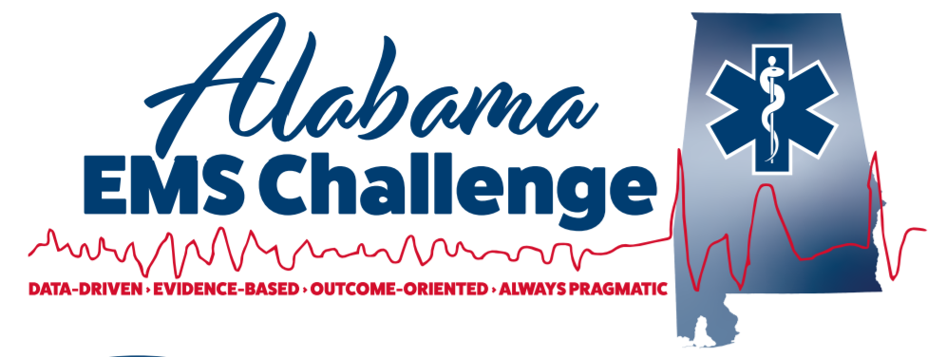
March 22nd , 2023, at 9am (0900-1100) at Talladega Superspeedway, 3366 Speedway Blvd., Talladega , Al,35160 (See details /map )
Physician-Led Continuing Education for EMS Providers
This is a great opportunity for EMS providers, nurses, students, or anyone interested in emergency medicine.
Come in person or join via MS Teams for the same credit
We now offer CME for Physicians, NP’s, in addition to Nursing and EMS CEU.
9:00-10:00: –Head and Facial Emergencies: Dr Ferguson
10:00-11:00 : Chest and Abdominal Trauma- Dr Davidson ,UAB EMS Fellow
Lunch Provided then from 1200-1430: Skills lab with AEMSC Staff: Pit Crew CPR, Advanced Airway, Surgical Airway , The Basics of Ultrasounds, and selected Mega Code scenarios with the docs…Plus… Hemorrhage Control training thanks to Alabama Power .. and weather permitting ... Life Saver 4 and Al Army Guard MEDEVAC on site
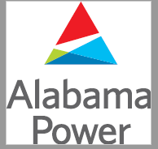
Don’t Miss Out!

Please contact Dr. Will Ferguson (willfergusonmd@gmail.com) or Wes Ward (wward@emschallenge.org) with any questions or concerns.
Follow on Facebook @ Alabama EMS Challenge/Twitter @EMSdocFerg
Check us out on YouTube here.
March 22nd at Talladega Speedway
https://teams.microsoft.com/l/meetup-join/19%3ameeting_YTYzYzM5MjYtN2QyMC00OTUyLWExOTktMjNmYWFlNTdhZDcx%40thread.v2/0?context=%7B%22Tid%22%3A%22eef12639-b2ba-4510-985a-6b9ef747076c%22%2C%22Oid%22%3A%22e89d7645-1eb7-4b53-b4d0-8095919ef19c%22%2C%22IsBroadcastMeeting%22%3Atrue%2C%22role%22%3A%22a%22%7D&btype=a&role=a
Turn in main entrance . If in a large truck , EMS vehicle, or fire apparatus please take the first left and follow the red line on the map to south tunnel. Once you enter the infield ,follow signs to the media center. (Red line on the map to the blue line and then left )
If in a private vehicle/ car , use the main entrance and go straight through the north tunnel, once you exit the tunnel turn right to the media center. (Blue line on the map) 