Medical Direction & Accountability Plan
for
Alabama EMS Region Two

2018

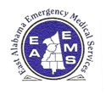

East Alabama Emergency Medical Services, Inc.

Medical Direction and Accountability Plan

Published by
Alabama EMS Region Two
August 2018

Approved By
ADPH Office of EMS
_____ 2018

East Alabama Emergency Medical Services, Inc.
Speedway Industrial Drive
P.O. Box 700
Lincoln, AL 35096
205.763.8400
205.763.8402 Fax
eastalabamaems.com
eaems@centurytel.net

Table of Contents

I. INTRODUCTION 4
II. PURPOSE & SCOPE 5
III. REGION TWO OPERATIONAL STRUCTURE 6
A. Regional Authority 6
B. Regional Office 6
C. Regional Medical Director 6
D. Medical Direction 7
E. Medical Direction and Accountability Committee (MDAC) 8
F. Quality Assessment/Quality Improvement 10
G. Alabama EMS System Components (Triage Agreements) 10
IV. MEDICAL DIRECTION AND ACCOUNTABILITY PLAN UPDATES 11
V. REGIONAL RESOURCE GUIDE (RRG) 11
APPENDICES 12

I. INTRODUCTION

Under the authority of the State Committee of Public Health and the Alabama Department of Public Health, the Office of Emergency Medical Services (ADPH/OEMS) has defined six Emergency Medical Services (EMS) regions to assure excellence and efficiency in the delivery of emergency care throughout the state. Each region is contracted to coordinate EMS activities and support state EMS and Acute Health Care System (AHCS) initiatives. The EMS region serves as facilitator, communicator, data collector, and coordinator for and between the ADPH/OEMS and to all EMS System components. The EMS System components include, but are not limited to EMS agencies, EMS personnel, hospitals, Emergency Management Agencies (EMA), 9-1-1, and Public Safety Answering Point agencies (PSAP). Each EMS region has the responsibility to provide a Medical Direction and Accountability Plan (MDAP) for each component of the EMS System. The regional EMS organization for the ten counties of East Alabama is Alabama EMS Region 2, East Alabama EMS, Inc. (EAEMS).

II. PURPOSE & SCOPE

The purpose of the MDAP is to provide a single document that can be used as a resource identification and documentation tool. The scope of the MDAP is deliberately broad and is intended to include the activities and capabilities of all organizations, government agencies, and businesses that may have a role in anticipating or responding to emergency care events, major threats to health and safety (natural or man-made), or any other significant hazards which may present themselves in the region.
The mission of the regional agencies and the MDAP is to ensure the highest level of emergency medical care is provided to the citizens of Alabama through an enhanced EMS system. The system components include, but are not limited to trauma, stroke, and cardiac through the utilization of a statewide-centralized communications center.
Key goals of the MDAP include:
- Facilitating educational needs identified for the improvement of patient care.
- Identifying the medical direction capabilities of all hospitals within the region.
- Establish mechanisms for reporting and validating the quality of care issues between EMS agencies, EMS System components, and the ADPH/OEMS.
- Facilitating the signing of memorandums of understanding (MOUs) between the ADPH/OEMS and the medical direction hospitals (MDH) within each region.
  - Establishing a Medical Direction and Accountability committee (MDAC) to provide a forum to share ideas and express concerns.
  - Providing guidelines for mediating issues involving EMS system and its components.
  - Creating and maintaining a Regional Resource Guide (RRG).
  - Providing MDAP revisions and MDAC reports to the ADPH/OEMS.
The MDAP and MDAC are not regulatory in nature, nor do they create a regulatory authority. Elements of the MDAP should not be considered rules or regulations.

III. REGION TWO OPERATIONAL STRUCTURE

A. Regional Authority
Alabama EMS Region Two (EAEMS) has a contractual obligation with the ADPH to coordinate EMS activities in Region Two. Regional personnel answer directly to ADPH officials in matters regarding Region Two activities. As required by the ADPH contract, Region Two shall schedule and coordinate quarterly meetings with representatives from the Alabama EMS staff, each of the region’s medical direction hospitals, and EMS provider services in the region to discuss medical direction and other relevant issues.
EMS Region Two is composed of 10 counties, as defined by ADPH:

  - Calhoun
  - Chambers
  - Cherokee
  - Clay
  - Cleburne
  - Coosa
  - Etowah
  - Randolph
  - Talladega
  - Tallapoosa

B. Regional Office
The Alabama Region Two office is located at 58 Speedway Industrial Drive in Lincoln, Alabama. The main phone number is 205.763.8400, and the e-mail address is eaems@centurytel.net. Official office hours are 8 a.m.-5 p.m. Monday through Friday.
EAEMS’s mailing address is:
P.O. Box 700
Lincoln, AL 35096

C. Regional Medical Director
The regional agency shall nominate a regional Medical Director and the ADPH/OEMS shall approve the nominee. The Medical Director is a medical control physician (MCP) and also serves as an off-line source of medical information. See Appendix B-9.

D. Medical Direction
Medical direction must be provided by a medical direction hospital or the service’s designated Medical Director if he/she has a current Medical Control Physician Identification (MCPI) number.
D1. Hospital Designations
Medical direction hospitals are defined as those hospitals that provide online medical direction by physicians with current medical control physician certification and MCPI numbers. Medical direction hospitals have full-time licensed emergency physician coverage with medical direction physicians possessing a current MCPI number in the emergency department, 24 hours per day, 7 days per week. Hospital designations will be recognized through voluntary MOU documents established between the hospitals and the ADPH. Hospitals that do not provide On Line Medical Direction are referred to as non-medical direction hospitals. All medical direction for patients transported to non-medical direction hospitals must come from a medical direction hospital or from the service’s designated medical director if he/she has a current MCPI number. See Appendix B-8-A for hospital designations and facility information.

D2. Memorandums of Understanding
Success of the MDAP depends upon effective cooperation, organization, coordination and planning among hospitals, EMS agencies and the ADPH/OEMS. Therefore, medical direction hospitals within each region agree to sign a MOU establishing medical direction designation with the ADPH/OEMS. Region Two will assist the ADPH/OEMS in obtaining MOUs from hospitals within the East Alabama region.

D3. Licensed Services
All licensed services have an offline medical director who is approved by ADPH ADPH/OEMS. This offline medical director is responsible for all patient care provided under the approved protocols. Drugs and Procedures (Category A & B) are signed by the ordering or receiving medical direction physician or by the service’s designated off-line medical director. Medical direction is obtained from the receiving hospital if that hospital is a medical direction hospital or from the service’s designated medical director if he/she has a current MCPI number. A medical direction hospital or the service’s designated medical director (if he/she has a current MCPI number) may be contacted if the receiving hospital is a non-medical direction hospital. See Appendix B-8-B for Region 2 Licensed Services and Appendix B-8-E for Region 2 Offline Medical Directors.

D4. Medical Accountability
The ADPH/OEMS is responsible for all EMS issues related to medical accountability in Region Two and throughout the state. Unless otherwise specified in the State’s EMS System components, all complaints or patient care issues are handled in accordance with the policies established by the ADPH/OEMS.

E. Medical Direction and Accountability Committee (MDAC)
Region Two will establish a regional medical direction and accountability committee made up of EMS System components to be chaired by the region’s medical director. The region shall be segmented into four zones. Zone A (Cherokee and Etowah Counties), Zone B (Calhoun, Cleburne, and Talladega Counties), Zone C (Coosa, Clay, and Tallapoosa), and Zone D (Chambers and Randolph Counties) shall each be represented by an associate medical director. The committee will hold meetings at least once per quarter providing a forum to express concerns and share ideas.

EAST ALABAMA EMS – REGION 2

MEDICAL DIRECTION ZONES

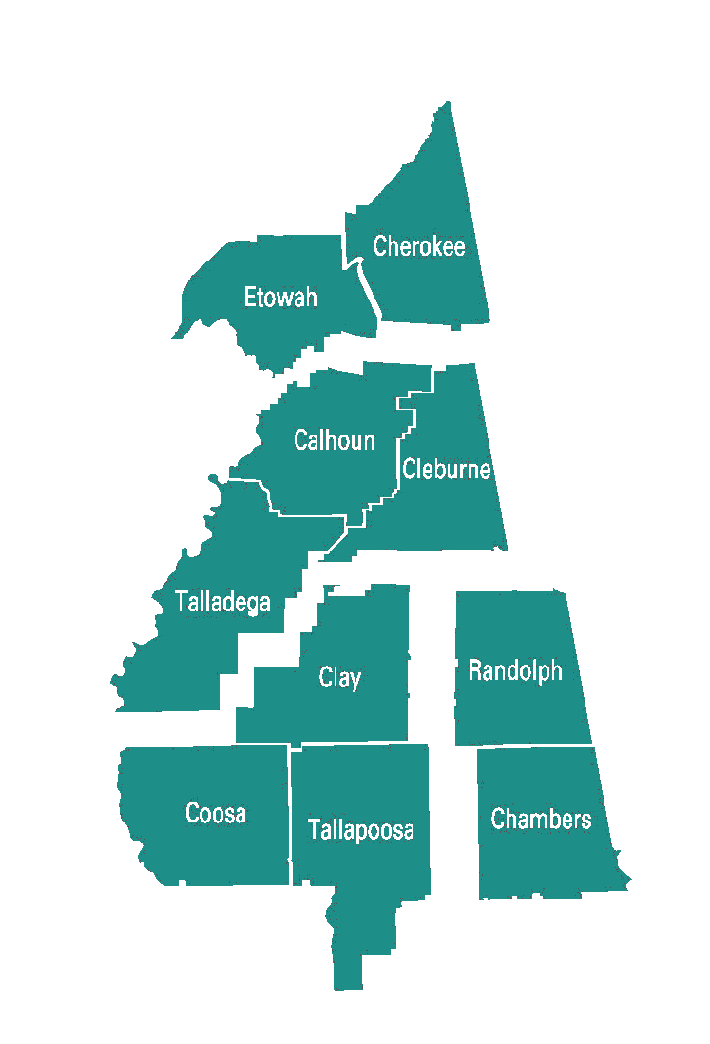
ZONE D

Chambers & Randolph

ZONE C

Coosa, Clay, & Tallapoosa
ZONE B

Calhoun, Cleburne, & Talladega

ZONE A

Etowah & Cherokee

CONTACT INFORMATION
East Alabama EMS, Inc.
PO BOX 700
58 Speedway Industrial Drive
Lincoln, AL 35096
Phone: 205-763-8400
Email: eaems@centurytel.net

www.eastalabamaems.com

Membership of this committee should consist of:

- The Regional Medical Director (chairperson)
- The On Line Medical Director or their designee of each hospital providing medical direction.
- The off-line medical director of each licensed EMS provider service.

The MDAC is not a regulatory committee. Its purpose is to provide access to the regional medical director and to provide a forum for discussions on how to improve emergency medical care throughout Region Two. See Appendix B-8-H for MDAC membership.

F. Quality Assessment/Quality Improvement
All hospitals and EMS agencies in the region should have QA/QI processes in place to ensure that they are delivering quality emergency care. The state’s EMS System components also have QA processes embedded in them.

G. Alabama EMS System Components (Triage Agreements)
Alabama EMS System Components plans establish responses to unique emergency situations. Region Two will support all state EMS system component plans in accordance with the ADPH ADPH/OEMS contract, which currently include:
- Alabama Trauma System – see Appendix B-4
- Air Medical Plan – see Appendix B-5
- STEMI (Cardiac) – see Appendix B-6
- STROKE – see Appendix B-7

IV. MEDICAL DIRECTION AND ACCOUNTABILITY PLAN UPDATES

Region Two will review and modify the Regional Resource Guide (RRG) as needed and report modifications to the ADPH/OEMS. The ADPH/OEMS must approve all MDAP revisions. The ADPH/OEMS Director will sign the revised document. The entire document will be updated and redistributed, with a revision letter summarizing the changes. The release date should be indicated on each page of the MDAP. Region Two will archive all versions of the MDAP in its Lincoln office.

V. REGIONAL RESOURCE GUIDE (RRG)

EAEMS Region 2 Resource Guide can be found in Appendix B-9.
It provides a look at the region’s resources such as:
- Hospital designations, facility information, and ER personnel information
- Licensed and Unlicensed Services contact information
- Regional 911 contact information
- Regional EMA contact information
- Regional Offline Medical Director contact information

The RRG shall be updated and reported to the ADPH/OEMS as needed.

APPENDICES

Appendix A: Acronyms
Appendix B: Reference Documents
Appendix B-1 ADPH EMS RULES
Appendix B-2 ADPH/OEMS Patient Care Protocols
Appendix B-3 ADPH/OEMS Provider Services Operational Guidelines
Appendix B-4 ADPH EMS REGION 2 CONTRACT (On-File in Region 2 Office)
Appendix B-5 EAEMS Regional Trauma System Plan
Appendix B-6 EAEMS Regional HEMS Plan
Appendix B-7 EAEMS Regional STEMI Plan
Appendix B-8 EAEMS Regional STROKE Plan
Appendix B-9 REGIONAL RESOURCE GUIDE
Appendix B-9-A EAEMS Region 2 Hospitals
Appendix B-9-B EAEMS Region 2 Licensed Services
Appendix B-9-C EAEMS Region 2 911 Contacts
Appendix B-9-D EAEMS Region 2 EMA Contacts
Appendix B-9-E EAEMS Region 2 Offline Medical Directors
Appendix B-9-F EAEMS Region 2 Hospital ER personnel
Appendix B-9-G EAEMS Region 2 Unlicensed Services
Appendix B-9-H EAEMS Region 2 MDAC Members
Appendix B-9-I EAEMS Agency Fact Sheet

Appendix B-10 EAEMS Region 2 Medical Director Resume

APPENDIX A: Acronyms

ACLS………. Advanced Cardiac Life Support
ATLS………. Advanced Trauma Life Support
ADPH……….Alabama Department of Public Health
AERO……….Alabama EMS Region One
BREMSS……Birmingham Regional EMS
BLS…………Basic Life Support
EAEMS……..East Alabama EMS
WAEMSS….. West Alabama EMS System
GEMSS……..Gulf Regional EMS System
MDP…………Medical Direction Physician
MDH……….. Medical Direction Hospital
MDAP……… Medical Direction and Accountability Plan
ADPH/OEMS….. Office of Emergency Medical Services and Trauma
RRG…………Regional Resource Guide
EMS…………Emergency Medical Services
EMA……….. Emergency Management Agency
MCPI Medical Control Physician ID
PSAP………. Public Safety Answering Point Agencies
SEAEMS……Southeast Alabama EMS System

APPENDIX B: Reference Documents

Appendix B-1 ADPH EMS RULES
Appendix B-2 ADPH/OEMS Patient Care Protocols
Appendix B-3 ADPH/OEMS Provider Services Operational Guidelines
Appendix B-4 ADPH EMS REGION 2 CONTRACT (On-File in Region 2 Office)
Appendix B-5 EAEMS Regional Trauma System Plan
Appendix B-6 EAEMS Regional HEMS Plan
Appendix B-7 EAEMS Regional STEMI Plan
Appendix B-8 EAEMS Regional STROKE Plan
Appendix B-9 REGIONAL RESOURCE GUIDE
Appendix B-9-A EAEMS Region 2 Hospitals
Appendix B-9-B EAEMS Region 2 Licensed Services
Appendix B-9-C EAEMS Region 2 911 Contacts
Appendix B-9-D EAEMS Region 2 EMA Contacts
Appendix B-9-E EAEMS Region 2 Offline Medical Directors
Appendix B-9-F EAEMS Region 2 Hospital ER personnel
Appendix B-9-G EAEMS Region 2 Unlicensed Services
Appendix B-9-H EAEMS Region 2 MDAC Members
Appendix B-9-I EAEMS Agency Fact Sheet

Appendix B-10 EAEMS Region 2 Medical Director Resume

DOC/DISK P: SC2018/MDAP 2018

