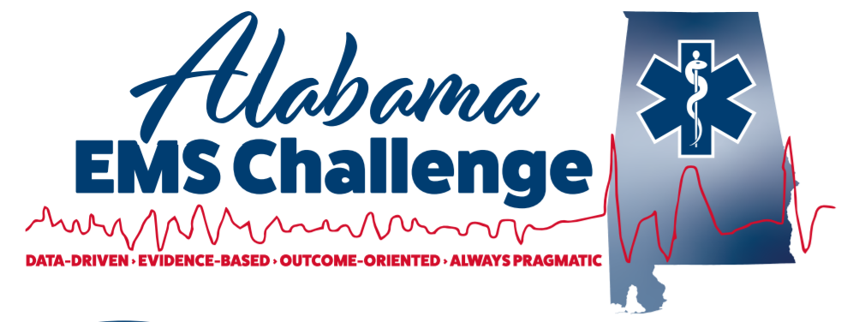
February 22nd , 2023, at 9am (0900-1100) at Childersburg Fire Department, 122 6th Ave SW, Childersburg , Al, 35044
Physician-Led Continuing Education for EMS Providers
This is a great opportunity for EMS providers, nurses, students, or anyone interested in emergency medicine.
Come in person or join via MS Teams for the same credit
We now offer CME for Physicians, NP’s, in addition to Nursing and EMS CEU.
9:00-10:00: – 12 leads and Select Medical Cases -Dr Ferguson
10:00-11:00 : Hemorrhage control and fluid resuscitation- Dr Blake Davidson
Lunch Provided then from 1200-1430: Skills lab with AEMSC Staff: Pit Crew CPR, Advanced Airway, Surgical Airway , The Basics of Ultrasounds, and selected Mega Code scenarios with the docs!!! Did you need ACLS Check off ? Completed the online course ? We can do that.
Don’t Miss Out!
Please contact Dr. Will Ferguson (willfergusonmd@gmail.com) or Wes Ward (wward@emschallenge.org) with any questions or concerns.
Follow on Facebook @ Alabama EMS Challenge/Twitter @EMSdocFerg
Check us out on YouTube here.

Feb 22nd at Childersburg Fire
https://teams.microsoft.com/l/meetup-join/19%3ameeting_ZWZhYjNlZTQtYzRhYy00ZTVlLWExZTYtZGZiYWNlNzFlMmRi%40thread.v2/0?context=%7B%22Tid%22%3A%22eef12639-b2ba-4510-985a-6b9ef747076c%22%2C%22Oid%22%3A%22e89d7645-1eb7-4b53-b4d0-8095919ef19c%22%2C%22IsBroadcastMeeting%22%3Atrue%2C%22role%22%3A%22a%22%7D&btype=a&role=a

