Dr. Crawford’s EMS Protocol 10th Edition Presentation (February 1, 2022) Edited Transcript
Appreciate all of y'all participating, this is going to be fairly informal. It is not going to be all inclusive. I'm going to hit the high points on the protocols updates and the training officers will need to go back and really sort of drill down to the new protocols. One thing I will say that, as you look at the new protocols, there's a new format. Some of you probably already looked at it. The New format is in an algorithm type of format, most of us in the EMS are certainly familiar with algorithms. I am going to sort of share that format with you now and then I'm going to reference back to this format in just a few minutes, as well as we continue to go through these protocols today. One thing I want you to sort of focus in on as we use General Patient Care (page 19) to explain, where it says all levels glucometer 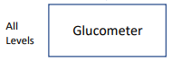and it says “consider IV access” 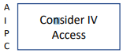and then “consider cardiac monitor” 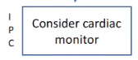obviously all levels is all levels EMS – basic, intermediate, advanced, paramedic, critical care, and “Consider IV Access” is advanced, intermediate paramedic, critical care and then “consider cardiac monitor” is intermediate, paramedic, and critical care. I'm not going to talk much about the critical care portion today. We don't really have any ground services in the region that are doing critical care that I'm aware of. I know that we have some critical care paramedics out there and I encourage you to look at those protocols that pertain to you, but I'm not going to really talked much about the critical care portion of this today.
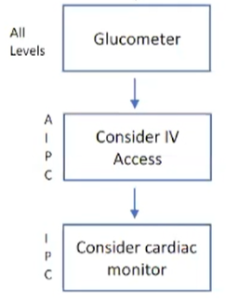
Now all of the protocols are in this same type of format where to the left of the treatment boxes, there will be those letters and, if you look at those letters and look at the treatment block and if you see your level there, that means you can do that treatment, so you'll need to learn, each one of those boxes and those protocols and for that reason it's sort of hard for me to go over it, word for word, you're just got to learn these protocols. Most of these protocols, to be honest, they are not new. There are some new things that different levels got. I the Advanced levels, probably got most of the new medications and a new things to do as an Advanced and Intermediate as opposed to the Paramedics and the EMT, but again you just got to look at your treatment blocks and learn what your level can do.
One thing I will make a comment on this is a Category A Protocol Book. That means you don’t have to call for orders any longer. There’s only one time in these protocols that you will call for orders and that is for a pediatric intubation less than three years of age – you’ll need to call for orders. That does not mean that you can't call and talk to medical control, as a matter of fact, we encourage you calling and talking to medical control. You have a question, we'd much rather hear from you and guide you and not have mistakes made, as opposed to making a mistake that you know, and then we have to sort of pick up the pieces after that. So, the Category A was not ever meant that “hey, we don't have time and we don't want to talk to you.” It was just basically, you know, unhandcuffing you, so that you can work within your training and do things you have been trained to do and you are professionals and we, basically, want to turn you lose and let you do what you have been trained to do.
I’ll talk a little bit about Adult tachycardia, and the reason I'm going to talk about, that is sort of out of order is, you will see, on occasionally on some protocols and adult tachycardia comes to mind, where you'll have a treatment box, it says “consult online medical control or online medical direction,” and the reason that it is there is to give you just time to sort of pause. Sometimes these are a little bit of a complicated treatment algorithms with the Adult tachycardia, where you got a lot of steps, and you know, is it narrow complex, is it irregular, is it stable, is it unstable - it's just a lot of different decision trees at that point in time. It doesn't mean that you have to call medical control, it just basically, sort of reminds you “hey, we're getting off in deep water here, and if you want to contact medical control, and we encourage it, but you don't have too. Really and truly, the only time you have to call medical control for these new guidelines is for pediatric intubation less than age three. But, again, it just basically gives you pause to look into maybe I need some help here.
A little bit of housekeeping issues, I probably should have said at the beginning. 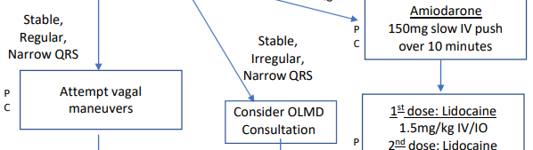
You see “consider online medical direction consultation” As you see, that's a pretty busy protocol right there, but basically, a stable irregular narrow QRS you know, is it atrial fib with RVR, is it, you know, just SVT, what is it, so this is an example of where Medical Control can help You.
Look, I know there are going to be questions about these protocols, I will try to take these questions now and for those questions that come up later, and other people have the same question, reach out to me and we will have you an answer.
Alright, with all that being said, we’re going to start with the new medications and some of these are not new medications, they’re just medications that certain levels now can use. So, we’re going to start with acetaminophen, which is just plain Tylenol. We have added that for mild pain and we’ll look at our pain management protocol in a little bit, but basically, they are sort of severe pain and there is mild pain. And, that mild pain or fever, we can certainly give Tylenol ore acetaminophen and I’ll talk a little bit about the dosage a little bit here and in the protocol and talk about in the actual protocol, but it’s basically for Tylenol or acetaminophen and for a kid is 15 milligrams per kilogram up to a dose of 1000 milligrams and again that’s fever, pain, this is a sort of a mild type pain and all levels of the EMT, intermediate, advanced, paramedic; anybody can give that medication. Contraindications - obviously look at liver disease; liver disease we probably should not give the Tylenol.
The next medication is Albuterol or Duoneb (ipratropium/albuterol) is a combination of albuterol and Ipratropium Bromide. All levels can give that, the intermediate and advanced and paramedics have been able to give it, but we added that to the EMT level of certification as well and that, after all, you can use it for asthma and COPD there are some other indications that you can use with If you call medical control now and I will stop and make one more comment about some of these medications. Many medications have multiple different indications. We did not include those medications in the protocols with every indication, and this is a prime example for somebody that's in renal failure and they're hyperkalemic and bradycardic and but they're not in cardiac arrest again, you can actually give them an albuterol nebulized treatment or updraft or whatever terminology you want to use, and that will help drive that potassium inside the cells, but we don't really include that in the indications. So, the reason I touch on that is that a medical control physician may tell you to give that medicine that's really not within the protocols and that's perfectly fine if that medical control doctor tells you to give it. Now, obviously, if they tell you to do something that you know is wrong and don't follow that order, but if they tell you do something that's reasonable then follow that so I'm going to touch on that there's no way that we could have added every indication for these medications but for the most part Albuterol at all levels is going to be used for asthma, COPD, you can use it for congestive heart failure it's not really in the congestive heart failure protocol; that's another time that you could call medical control that they're wheezing and try to get orders for that.
Epinephrine 1:10,000 now the advanced and the intermediates have been able to give 1:1000 for allergic reactions, but we added the 1:10,000 this year, which is the cardiac “EPI.” For all of us and we added that for cardiac arrest only now I understand that we can give 1:10,000 EPI for other things such as allergic reactions, not SUBQ, but you can do it for other things you can do it for push dose Epi, for a lot of different things, but, we have limited the Epi 1:10,000 for intermediates and advanced for cardiac arrest and cardiac arrest only; now that for pediatric and for adults and you can repeat that every three to five minutes if you need too. So, 1:10,000 Epi and intermediates and advanced; it is a new medication for them only in cardiac arrest.
Another new medication for across the board for advanced, intermediates, paramedics is Solu-Medrol or Methylprednisolone, which is a steroid. And, we added that on several of our protocols, we added it on adrenal insufficiency, added on COPD, we added it on allergic reaction, so there are lots of different ones that we added that on. That's for advanced, intermediate, and paramedic. Now there are some contraindications for Solu-Medrol. One is active tuberculosis. Somebody is already hyperglycemic because Solu-Medrol or any steroid may increase your blood sugar levels so if they're already hyperglycemic, you need to sort of have a bit of a pause there, do I really need to give this and this may be a time that you can consult medical control. It is not an absolute contraindication that you don't give Solu-Medrol or steroids to somebody who's already hyperglycemic; what you really need to do is weigh the benefits versus the risk. Somebody that's got an actual fungal infection, I know we might not know, in the field, where somebody who's got a fungal infection, but sometimes with a good history, the patient or the family may say “hey, they're being treated for this, treated for that, so fungal infection. Again, if you're unsure, call medical control - we are there. Some side effects from Solu-Medrol, you can get some dysrhythmias, can cause bradycardia, it can cause a headache. I've never seen it cause a dysrhythmia, I've never seen a cause a bradycardia, but it potentially could; but I’ve never known that potential could; but I’ve never known it to do that.
The next medication is Midazolam or Versed. Again, that’s not a new medication for the paramedic level, but it has been added to the advanced and the intermediate level for seizures and seizures only. The dosage is 0.2 milligrams per kilogram up to a total dose or max dose of 5 milligrams and as intranasal only. We’re not allowing it IV or IM for the advanced or the intermediate level, intranasal only. If you remember anytime we give intranasal medicines will really need an atomizer, it's very similar to administering narcan get an atomizer, put on the end of the syringe and give it intranasally, if somebody seizing. Again, that's an advanced, intermediate. There are some side effects. You know, one of the biggest side effects, obviously, is the apnea or decrease respiratory drive. It can cause some hypotension and cause dysrhythmias. I would say that many times when we're treating the seizures with intranasal Versed that we're actually probably don't have an IV yet. But once you get that seizure under control or if you can go ahead and get that IV in and try to get an IV, just don't give that Versed IV, but go ahead and get that IV in place, because many times they'll drop their pressure after that intranasal Versed and Not a big deal, we just need to give them a 500 cc bolus or liter of fluid and just watch it most the time it comes up is no big deal just watch that and also the apnea or decrease respiratory drive again that's something that that you may see with Versed and not very common with intranasal Versed, but it can cause and just need to make sure that you can support their respirations with a bag valve mask and most of the time after You know couple minutes of bagging them everything's over and they're breathing on their own again but, again don't be afraid to use it, because if you have a seizure. Then we obviously need to stop those seizures but just keep in mind some of the sort of side effects of the Midazolam or Versed.
One of the other medications actually two medications sort of one class that we're going to talk about and that's the antibiotics; going to talk about Rocephin and Ancef (Cefazolin) and the Rocephin is s also called Ceftriaxone and the Ancef is called and depends on how you pronounce it, Cefazolin. The Advanced and the Intermediate and Paramedic all three levels, they can give the Rocephin or the Ancef. There are two indications of when we would want you to give these antibiotics. And that’s the one for sepsis and we’re going to talk a little bit about the individual protocols, in a few minutes, and the other indication is open fractures and the traumatic injured patient. So, keep that in mind – sepsis and open fractures. There are some contraindications to any medicines and antibiotics are one that we really need to pay attention too, if they have an allergy or hypersensitivity reactions to that medicine in the past. Obviously, we would not want to give it. Now, there is some thought process that has pretty much been debunked over the years that people who have a penicillin allergy should not receive those two medications. These medications belong to a big sort of a big category called cephalosporins - that's the type of antibiotic they belong to, the antibody class they belong too. There is, like I said, has been some thought process that in the past with their penicillin allergic, they could have some cross reactivity to this - that is extremely rare. Most of the people, if they have an allergic reaction, they're going to have an allergic reaction to a Rocephin or one of their close relatives - You know, one of the other cephalosporins. I think that's where medical control comes in and I don't think you should worry yourself with memorizing every antibiotic, if you have a patient that is allergic to something then by all means call medical control and say “hey, I've got this patient, allergic to this antibiotic their septic I'm going to give them some Rocephin, and is there any reason I shouldn't give that Rocephin with that allergy.” Let medical control help you there, but just keep in mind, if there's an allergy to antibiotics, you need to make sure that we're not giving them Rocephin or Ancef. So, if there's any chance that they could be allergic to something similar. So, just keep that in mind and we're going to talk about both of those a little bit more in a few minutes.
The next medication is Toradol, which is non-narcotic pain medicine. It is what we call an NSAID - Non-Steroidal Anti-Inflammatory Drug. It's like Motrin, in IV form of Motrin or Naproxen - very similar there's an oral form of Toradol as well, but we're not going to be giving that form, we're going to be giving the IV form, and that has been added to paramedic, advanced, and intermediate and that is for sort of a moderate type of pain. Now, I know that we're probably not going to do a pain scale in the field, although the protocol does say a pain score greater than 5 out of 10, should get morphine or fentanyl and I know not many of us are not carrying morphine and fentanyl, so we would probably go to Toradol. The background information on all of this is that we're trying to get away from Ketamine for acute pain control. Ketamine is a great drug for agitated delirium, excited delirium, agitated patients, psychotic patients - for those types of patients. And, but it's not a great drug for pain control. Does it work for pain control? Absolutely, but it's just not the best medication to use for pain control. So, with that being said, we would rather use Toradol obviously better than that is morphine or fentanyl, understanding we're not all carrying that, but the Toradol is a great medication. It works great for kidney stones, it works great for lots of different things. Now, one thing I would tell you about Toradol, there are some contraindications to Toradol. One of the things that you probably need to keep in mind is we're running on older and older patients and you really should think and have a bit of a pause before you give Toradol to an older person. Anybody that has renal insufficiency, somebody is already on dialysis, somebody is already sort of on the borderline of going on dialysis. We really should not give Toradol and in keeping with that same line of thought. You know, older people have renal insufficiency just as a baseline, many of them anyway, and so we really should not give Toradol at that, to the older people. If they've had a stroke or traumatic brain injury within the last 24 hours, we should not give Toradol. Toradol can increase the chance of bleeding and that's the reason you don't give it. Somebody who has had an another NSAID - Motrin, Naproxen, Advil – recently, I usually say eight hours, if they've had some within the last eight hours, then I'm not going to give them Toradol IV, but again Toradol is a great medication. Non-narcotic is for that next step in the pain control protocol past acetaminophen. And again, just keep in mind that older people, renal insufficiency we need to stop and think and maybe we shouldn't use that (Toradol).
Alright, the next medication is TXA. It is certainly not a new medication for the paramedic level. TXA has been used for bleeding and trauma patients. We've added that to the Advanced and Intermediate as well. Keep in mind that they (the patient) need to be greater than 15 years of age, before you give TXA. A child has been involved in some type of traumatic injury, we don't give TXA and the duration of Injury, basically the time between the injury and the time you give them TXA needs to be less than 180 minutes or three hours. If it's longer than three hours, we really should not be giving the TXA. TXA is a great drug that will help stabilize the clot. In that, hopefully the body's trying to clot off some of this bleeding and it stabilizes that and is a great medication for that. But again, greater than 15 years, less than three hours from onset of injury. Now, I'm going to jump off on a little bit of a tangent on TXA just a moment and TXA is a great drug that we could talk about different indications that we have not included in the protocols. TXA as a great medication for nosebleeds. It's a great medication for post tonsillectomy bleeds. You get these kids that come in the emergency department and they're bleeding you know they're 16, 17, 18 years old, or an adult they're bleeding or you get a 25-year old’s that comes in, with nosebleed. TXA is a great medication for those types of patients. We atomize the TXA in many times, we will take TXA, put it in syringe, put an atomizer on and atomize it and sometimes we will take gauze soaking in the TXA and put in the nose will spray it - atomized on the back of the throat, so it works very, very well. It's not in our protocols for that, however, this would be an example of medical control could potentially order that and it is perfectly fine for you to do that. If they give orders and indications for that, but we did not include that in the protocol, we can’t put every indication within the protocol. So, TXA greater than 15, less than 3 hours.
Alright that sort of finishes up the medication part. We’re going to talk about the actual Protocols, as you see, on all of that, the advanced and the intermediate got the lion share of the new medications. Paramedics got a few and the basics got Albuterol. And keep in mind that you know, the basics already have some medications, the advanced did not get anything taken away from them, that got things added to them and the Paramedic did not get anything taken away from them.
So, we’re going to talk a little bit about adrenal insufficiency protocol. And if you remember, I talked about Solu-Medrol. The Advanced, Intermediates, Paramedic, all can give Solu-Medrol 125 milligrams IM or IV in an Adult. The kids are two milligrams per kilogram IM or IV with a maximum dose of 125 milligrams. I will show you something on this adrenal insufficiency protocol, and this sort of holds true for many of the different protocols. I want to show you something on this protocol here.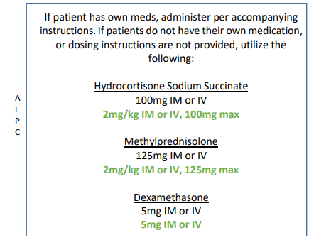
if you look at this protocol here and with adrenal insufficiency, I again, am not going to go over word for word for each one of these protocols. You're going to need to get in the book and you're going to need to get in these protocols with your training people and go over signs and symptoms of adrenal insufficiency, etc. This sort of protocol update is not really meant to teach, reteach all of these different conditions it's basically how to treat those. But adrenal insufficiency, most of time, they know they have adrenal insufficiency - their “shocky,” been vomiting, they've been sick, they're pale, etc., but if you look here, and you look at Hydrocortisone or Methylprednisolone and Dexamethasone. All of those medications are steroids, the Hydrocortisone is probably the number one medicine that you could use. We're not carrying that, we're carrying the second one, the Methylprednisolone, which is Solu-Medrol. Many of these patients will already have that had Hydrocortisone as a personal medication, so they have that, then help them use their own medication. Now, why are we not using hydrocortisone as opposed to Methylprednisolone. It's not really a second line drug, the Methylprednisolone. It's just a different medication and the Methylprednisolone, we can use it for different things. So again, what I want you to take away from this slide is that any of those three medications can be used, we don't want you to have to carry every one of these medications so we pick one that we think has fairly good utility, that's fairly cheap, fairly easy to mix, making it easy own you and that's the reason we checked the second one in all of those boxes, Methylprednisolone, (Solu-Medrol) so just keep that in mind, there are multiple medicines that you can use for this, Solu-Medrol is just one of those. We, also, have this same thing with hypoglycemia and seizures that you'll see a few minutes. So, adrenal insufficiency, I would encourage you to make sure that you follow and learn about adrenal insufficiency and go through that Protocol with the signs and symptoms, because if you're not looking for adrenal insufficiency, you'll miss it. So, just keep that in mind.
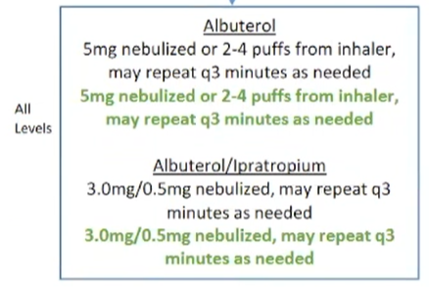
Alright moving ahead: Asthma and COPD we've added Albuterol to the EMT scope of practice so all levels can give Albuterol or Duoneb, a combination of hypertrophy bromide in Albuterol, but you're perfectly fine to give either one of those, Albuterol or Duoneb, you can give it in the. Some people call a nebulizer, some people call them up draft, whichever one you want to call it.
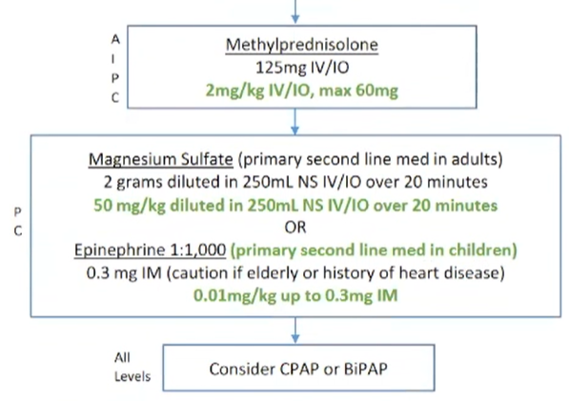 The Solu-Medrol can also be used and asthma and COPD again remember advanced, intermediate, and paramedic. Asthma and COPD is fairly straightforward, not a lot changed, other than we are adding Solu-Medrol to that treatment and adding Albuterol to the EMT level.
Adult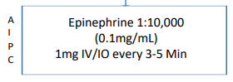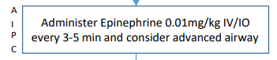Pediatric
Cardiac Arrest Adult and Peds: I've touched on this already EPI 1:10,000 for advanced and intermediate obviously the paramedics have had that so you can repeat that every three to five minutes if that's what you're you know, if you're following ACLS but it's only 1:10,000 for that and it's only in cardiac arrest the 1:1000 is perfectly fine for you to use allergic reaction for allergic reaction, but the 1:10,000 we've added for Advanced and Intermediate to treat the cardiac arrest, but again, they have to be in cardiac arrest.
Moving ahead, I've already touched on this and we've already actually cover this, so the Adult Tachycardia with the pulse, you know contact online medical direction because part of that not necessarily that Protocol is just wanting you to be aware of that, you may see one of the treatment blocks and some of these protocols that “hey, You Know, gives you a little bit of a pause there, maybe I need to contact medical control. I do want to backup since we already have it on the screen: 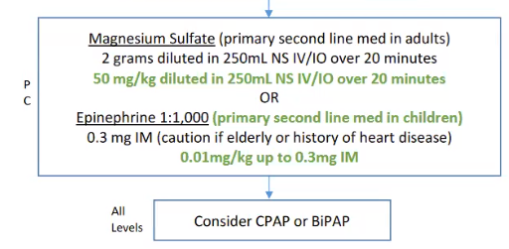
This asthma and COPD down at the bottom. Consider CPAP (Continuous Positive Airway Pressure) and BiPAP (Bilevel Positive Airway Pressure). This is not new, this has been at the level of the Basic, Intermediate, Advanced, Paramedic, but I do not see sometimes at the basic level are a little bit, hesitate to use it, some of them don’t even know that they can. CPAP and BiPAP, so you go through your protocol update’s this time make sure that the basics are well aware that the CPAP or BiPAP, doesn't really matter to us which one to use both of them work relatively the same about them have relatively the same outcomes this make sure that your Basic are using one or the other. If they need to use it and because, again it's just so they know. The ones that I have talked to and have asked them, “if they know that use it?” The say, “never been trained on it, etc.” So, just keep that in mind.
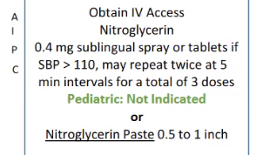
All right, Congestive Heart Failure in basically dovetail into what I just said. Some of these are new none of these are new treatments, but consider safe CPAP or BiPAP, again all levels and Nitroglycerin, either Nitroglycerin sublingual nitroglycerin spray, whichever one you want to use for the Advanced and Intermediate. If they're in Failure, you know, obviously, tachypneic and you can hear bilateral rales. They’re hypertensive, have a history CHF and those are things that sort of clue you in that they're in Congestive Heart Failure, and if they are and their hypertensive. That we want to reduce their preload and one way to reduce their preload obviously is nitroglycerin so the Advanced and the Intermediate level and the Paramedic level, we can give sublingual or nitroglycerin spray. So, just keep that in mind.
Croup: 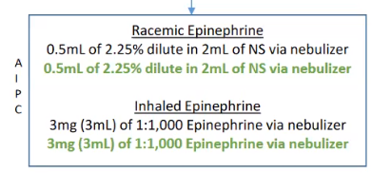
We have added Racemic EPI to the Advanced and Intermediate. So just keep that in mind. Actually, I think may have been there in the past, and I really never paid much attention. Advanced, Intermediate, but just keep that in mind that on Croup Racemic EPI can be used for Croup.
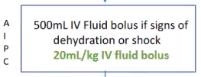
Hyperthermia nothing really new on the hyperthermia. Just wanted to clue you in that on hyperthermia patients that have a Fever, Tachycardia. Give them IV fluids, if you think they're in shock or dehydration many of these people will be dehydrated, so give them 500 CC bolus of Normal Saline.
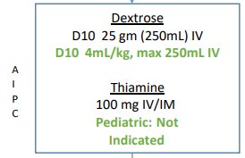Hypoglycemia: I want to talk a little bit about Advanced, Intermediate, Paramedic, and even the EMT, if they're still alert; give oral glucose. Now, one of the things that you'll see on the treatment block for hypoglycemia, you will see D10 and you may ask, or may say, well, what about D50, we can give D50, we can give the D25 or D5, you are absolutely correct, we can use all of those. What we prefer is D10 because it's fairly readily available, we're still having trouble getting D50. Right now, there's a back order on D50, D10 for the most part has been more stable than some of the others, I know we've had issues with that too, but it's been more stable with getting some. As far as getting supplies of that, the D10 in adult is 250 milliliters IV and usually even, in some ways and renal failure of whatever that 250 cc's is not going to matter and not going to hurt them, and it will get your blood sugar up. Now, what I will many times do in the emergency department, if I give that 250 milliliters. Then, I will follow up, if their fluid overload or if I think they could potentially be fluid sensitive, I'll give them 30 cc's an hour of that D10 and if they're not fluid sensitive then I might give them 50 or 60 cc’s an hour and monitor that blood sugar and 30 minutes or so. Now, with the kids you can also use D10. I would do with the current thinking is 4 milliliters per kilogram. In the pediatric population, not to exceed the adult dose or 250 ccs/milliliter. So, again I'm an adult 250 milliliters on a child, 4 milliliters per kilogram up to 250 cc. Now again, keep in mind is our I know I'm repeating myself, but you can use D50 you can use D25, you can use D5. But, we really like you to use D10, but if that's, if you don't have D10, you can't get D10, and you can use other medications.
What we've tried to do on some of these protocols is make it to the point where we're freeing you up a little bit to treat with different medications so that you're not having to call the state office. I can't get D10; I can't get D50; I can't get D25; and allow you several different choices within that treatment algorithm so that's part of the reason that we did that.
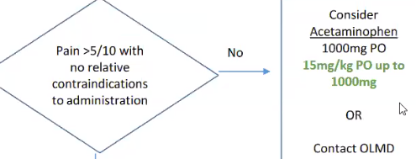
Pain Management: Again, I've touched on this with mild pain; Acetaminophen or Tylenol 1000 milligrams, but on a child, you get 15 milligrams per kilogram up to a maximum of 1000 milligram. I think there is a thing in there that talks about contacting online medical control and the reason that we have that in there is that you know, if you got somebody that potentially could be going to surgery and you're given an oral medication so just if you need to obviously contract medical control.
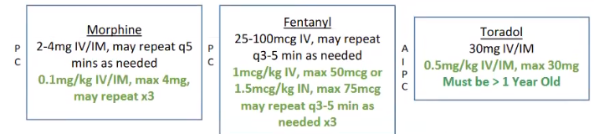
This is the morphine and Fentanyl and Toradol. The Morphine and Fentanyl for paramedic and again obviously critical care medics but the Toradol can be used by Advanced, Intermediate Paramedic and obviously the Critical Care. Toradol is O.5 milligrams per kilogram to a maximum of 30 milligrams. Basically, for most adults you're going to give 30 milligrams IV. Now, you can use up to 60 IM. But, we just sort of simplified and said 30 milligrams IV, or IM. So just keep that in mind - 30 milligrams. They got to be greater than a year of age before we use the Toradol; we don't want to give it to anybody that's less than a year of age.
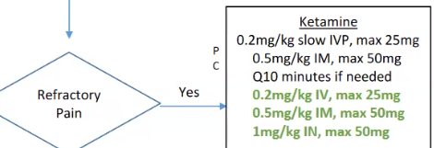
Ketamine: You can look at that again - this is refractory pain, we're trying to get away from ketamine. We are hopefully as a State will be carrying Morphine and Fentanyl across the board starting next year, so right now, you may have to use Toradol and may to go to Ketamine. For those of you who are not using morphine and fentanyl, now we know some of you are and I would encourage you to use Morphine and Fentanyl before you went to Ketamine. So those are the doses: Ketamine and you can go back and look at all the dosages. Always, if you need medical control by all means, please call us, we can guide you and any of this.
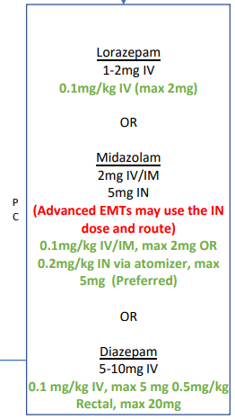
Seizures: We have added and I’ve already talked, obviously about the Advanced, Intermediate level, the intranasal Versed. Remember it is 5 milligrams Max for the 0.2 milligrams per kilogram intranasal. Keep in mind, it can drop your blood pressure, keep in mind, you can reduce the respiratory rate, so just be prepared to assist the respirations, be prepared to give the IV Fluids. One thing I want to make a note here, seizure in pediatric patients are commonly febrile seizures and usually are short lived and really don't have to do a whole lot for them. If they're back awake and able to swallow and their normal and they have a fever, then you can give them Tylenol is certainly not going to hurt these people. Keep in mind that pregnant women with seizures may be due to eclampsia and we need to use that appropriate protocol for preeclampsia/Eclampsia. One thing, if you look at the seizures, the same thing that holds true for the hypoglycemia there are multiple other medications that you can use, we recommend Ativan or lorazepam or Midazolam, which is Versed. Now, can Valium or diazepam be used? Absolutely, we’ve used that for years. I think the Lorazepam and the Midazolam is much better than diazepam or valium and, most of the neurologist here in Tuscaloosa are wanting to use Ativan or Versed. But, keep in mind, we try not to handcuff you down one pathway. That, if you can't get one medicine, then you can't treat the seizure, we actually opened it up a little bit so that you've got several different choices of medications, depending on what medication you get your hands on. But, if all three are available, then we would recommend Ativan or Versed.
All right, Sepsis: I want to talk a little bit of time on sepsis and spend just a little bit of time with sepsis. The mainstays of sepsis treatment are fluids and antibiotics. Now, what is sepsis, sepsis is basically an organ dysfunction caused by infection and the signs and symptoms of sepsis many times are hypothermia or hyperthermia. They can actually have a low temperature or obviously have fever many times they are confused as an older people they're confused they're tachypneic, their tachycardic, they have delayed capillary refill, sometimes they’re pale. You know, sometimes, a family will tell you “hey, they've had decrease urinary output,” many of these people are coming from the nursing homes, they have indwelling Foley catheters. They are an aspiration risk. So, they got a pneumonia, they got a UTI, we're seeing some of these with COVID now. So, most of us, have seen those patients, many of them come from the nursing home that are you know fever, course breath sounds where they probably aspirated their tachycardic and they're breathing 40 times a minute, they got a temperature, those are septic patients until proven otherwise. So, the mainstays of sepsis treatment is fluids and antibiotics. 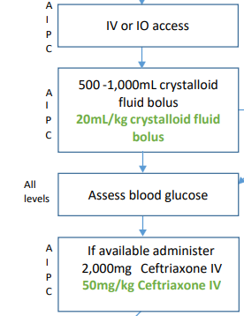
Now, the fluids, if you read a lot of the literature on sepsis, they tell you, that if a patient is hypotensive or their lactate is greater than 4, we really look at lactate in the emergency department to sort of gauge our thought process about the patient; Septic or Not? If their lactate is greater than 4 and are hypotensive, they really should get 30 milliliters per kilogram of IV fluid. So, some of these patients may be getting 2000, 2500, 2800 milliliters of IV fluid. We can't measure, a lactate in the field, I say we can't, we don't do it because the last time I checked, we're not FDA approved and it's hard to measure the lactate in the field. You can determine if they're hypotensive just by obviously monitoring their blood pressure, but it's sort of a middle ground, what we said is just give them a liter of fluid. You can start at 500 milliliters, I would recommend giving 500 to a liter of fluids of these people, whether they're really hypotensive or not, and you can repeat that, so you sort of start with 500. Watch them, if there are no signs or symptoms of overload and they're still showing tachycardia, still showing Tachypnea, still confused, you can give them another 500 cc's while in route to the hospital. So, basically 500 to a liter but they're really hypotensive, blood pressures in the 60s, or whatever, then try to figure that 30 milliliters per kilogram and give them that fluid. And one thing I will tell you, when you get to the hospital make sure you tell the nurse how much fluid they've gotten by you, but that's really important to the emergency department care. So, we will go over to the antibiotics now. If you remember, I talked to you about, we are carrying two different antibiotics; Ceftriaxone which is Rocephin or Ancef. Now, both of those medications can be used in open fractures, but with sepsis only the Ceftriaxone needs to be used. The Ancef, the Cefazolin really doesn't have great coverage for many of the bacteria that's causing sepsis and just remember; Sepsis equals Rocephin or Ceftriaxone or whichever term you want to use. This is a pretty cheap drug, remember that if they have any antibiotic allergies and you are unsure, pick up the phone, call medical control and ask them. But, Sepsis; fluids and antibodies. Those are two of the things that we have to do.
Now, when they come in the emergency department all the time we're going to give them antibiotics and we get blood cultures before we give them antibiotics. Now I talked with DCH and I know we're delivering patients to a lot of different hospitals in the region, but I have talked with DCH about do y'all want us to do the blood cultures before we give antibiotics and the thought process is well, One, we're not sure, with the uncontrolled environment you're working in, if you can really do sterile blood cultures. So, we may have you do those, that's not any more work. I have asked DCH if they wanted us to do that, if they would supply the blood culture bottles. So, there's not a cost to the services and they said they would. So, if we and they've actually said that they may even consider supplying the antibiotics for sepsis as well, because it really does help them on many of their metrics that they have to meet. So, with that being said, if we are going to do blood cultures, we will let you know, but by all means, give the antibiotics, fluids, antibiotics, you can start 500 milliliters, if they're still hypotensive or Hypoperfusing, give another 500 for a total of a liter, while you're in route to the hospital. Rocephin and Fluids. Obviously, if they are still hypotensive, even after the fluids, that we might have to add a presser, 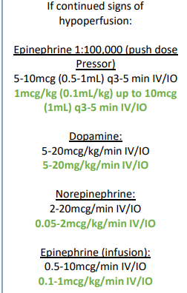we can add dopamine is what we're usually carrying. You can use other medicines, EPI infusion. I'm a big fan of push dose epinephrine right now. I think, is simple, especially for the rural paramedic, you're in the back by yourself. it's really easy just to have the syringe laying there. If they're hypotensive, every three to five minutes, you hit them, you know with a milliliter of that IV Push to get their blood pressure up; you know you watch them, if they drop it again, you give it another one and that really helps sort of with your workflow. You're not having to take the time to start, you know to hang a Dopamine Drip. So, I'm a big fan of the push dose epinephrine. I use a lot in the emergency department, so I would encourage you to really look at that and if you want to substitute that for dopamine, then you can certainly substitute that for dopamine. So, yes, push dose Epi. The way to do this, basically, is take a 10cc syringe, take put 9 cc of Normal Saline and only put 1 cc (0.1mg) of 1:10,000. They are, and you can use that 0.5 milliliter every five minutes. So, keep that in mind. So, just keep in mind with the push Epi. Alright, so sepsis: Fluids and Antibiotics.
I want to talk a little bit about General Trauma. Since we’re going to talk a little bit about antibiotics. With general trauma obviously TXA, if you remember advanced and intermediates can give TXA, it needs to be greater than 15 years of age. It needs to be less than three hours from onset of injury, you need to read about Trauma, you need to read about TXA, hypotensive patients, abdominal pain, I mean you know hypovolemic patients, hypotensive patient with a rigid abdomen; things of that nature is when you would use TXA.
Alright, Open Fractures: Open Fractures is an indication for an antibiotic. We’ve already touched on that. Again, Advanced, Intermediate, and Paramedic, you can use Rocephin and Ancef is Cefazolin. I would, you know, somebody brought up this morning, when I was talking with them this morning. One of the Tuscaloosa Fire guys brought up and he said well you know you could and he's exactly right, he said, if you wanted to you could just use Rocephin and not have to buy two antibiotics and I said you're exactly right. Now, I don't think that the Ancef or Cefazolin is great for sepsis, but I think the Rocephin. You can use Rocephin for open fractures and for sepsis. So, if you want to save some money, you wouldn't have to carry both. You could carry Rocephin. And that would handle your sepsis and it would handle your open fractures. So, you know, you can just check, if you want to have both of them, Great. My personal opinion is the Ancef, the Cefazolin - However, you want to pronounce it, is probably a little bit better for open fractures, but I think the Ceftriaxone or the Rocephin does a fine job of doing the open fractures as well. So, with all that being said, you could carry Ceftriaxone and have one medicine for both protocols.
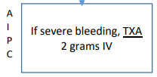Vaginal bleeding: The only thing I'll talk about vaginal bleeding is considered TXA. You got somebody that's having an uncontrolled vaginal bleeding with hypotension, consider TXA.
I'm going to finish up talking about strokes, most of you have heard about the EMSA Scale, the Emergency Medical Stroke Assessment Scale. We're getting away from the FAST exam and going to the EMSA. The EMSA was developed by Dr. Toby Gropen, who's the Director of Interventional Stroke Care at UAB. He has worked very closely with the State EMS Office to roll out this EMSA. We were actually going to start the training back in October I guess it was. And we did a little bit of training, but then COVID hit again and we back off on that. Starting on April, the first, when you have a patient that you enter into the stroke system and you call ATTC, they're going to ask you about the EMSA Scale. And the scale is here, the EMSA Stroke Scale is here. Then you'll just go through those. Now, if you haven't done the EMSA scale when you call the ATCC or if you don't know how to do it, then they're prepared to walk you through it. Show a little grace, don't give him a hard time, they're there to help you, the communicators are there to help you. They are very familiar with EMSA Stroke Assessment because they've been doing this in Birmingham for quite some time in the BREMSS region. So again, not the end of the world, if you don't know the EMSA scale, we're going to train you, we've already started that, we're going to get that training out. But what I would say is that starting on April the first be prepared to give an EMSA score to ATCC or if ATCC or if you don't know if they will talk you through it. The purpose of the EMSA scale is to identify what we call a large vessel occlusion. Those are arterial occlusion in the basilar artery, in the carotid artery, in the middle cerebral artery; there big arteries. Stroke care has evolved past TPA, you can actually go in at certain stroke centers and remove those clots from those large vessels. So that's the reason that we want to identify a large vessel occlusion as soon as possible. So, that we can route that patient to those what we call mechanical thrombectomy capable hospitals. We’re not one at DCH, UAB is, Brookwood is, several other hospitals, Tupelo is, Huntsville is, Grady in Atlanta, Dothan, Montgomery, Mobile; All of those hospitals are mechanical thrombectomy centers. We (DCH) have looked at that. I had a conversation with the stroke guys here two weeks ago about that. We're looking at the number of patients that we have and potentially the costs associated with that here. You know if it's not cost prohibitive, and we have enough numbers, I think we can probably convince the hospital to do that, but if there are only a few patients, then you know UAB and Brookwood have been very good about accepting the patients, even when they're on diversion. ATCC has been very good at helping us get those patients out. One thing, I will say is the current thinking is that, depending on how far you are from a Mechanical Thrombectomy Center. And, the jury sort of out; is it 15 minutes? is it 30 minutes? is an hour? that you may need to go to your local hospital, that's a stroke hospital and get TPA or Thrombolytics and then get transferred on over to a mechanical thrombectomy center. So, right now, we're not going to route, as of April, the first we're just going to collect the data, get everybody on the same sheet of music, as far as the EMSA Scale, so when ATCC asked you either have already done it, and if you haven't, then let them talk you through that and then we’ll look at the data statewide to see what our numbers are, as far as when we would route straight to a mechanical thrombectomy center. So, that’s something that you need to keep in mind and get familiar with the EMSA Scale.
I think that finishes up what I wanted to talk about again, this is not an all-inclusive protocol update. There lots of questions, I’m quite sure, and what I would suggest is people getting in these protocols, getting with their training people, and going through these protocols, and learning about adrenal insufficiency, learning about this, learning about that, and just getting very familiar with these protocols, but what we did today was a broad overview of the new things that have come out with these protocols.
I want to close by saying, one that don't hesitate to call medical control we're there to help you also want to say that I appreciate what you've done and what you continue to do. I know you had a tough, couple of years, lots of people don't understand what you do, day in and day out, I certainly do. And, and that doesn't get lost on me of what you've done. I've tried to tell people every day when I talk to them that the unsung heroes in all of this are the EMS personnel. So, again I'm proud of what you've done, you continue to make me personally, as a Regional Medical Director and State Medical Director, PROUD and if there's anything we can do, by all means call us. If there are questions, you have my phone number, call my phone number call me. If you don't have it, touch base with Glenn and Travis and we usually in conversation with them three or four times a day. If I'm not out here and we'll all get an answer back and again appreciate your time today and let's know when we can help you.
Questions and Answers:
Question: Does these Protocols go live March 1st?
Answer: Going live on the last Friday of April – April 29
Question: Do we need to make certificates for everybody that we're training, as we get through it.
Answer: You do not have to make certificates. You can send Travis Parker the roster of names and he will do the certificates.
Question: When will the Phone App be available?
Answer: The State does not do the Phone APP. That APP is a third-party vendor. But, Yes, I am quite sure that it will be available once all the corrections are done because I know Jamie is in conversation with them at this time.

