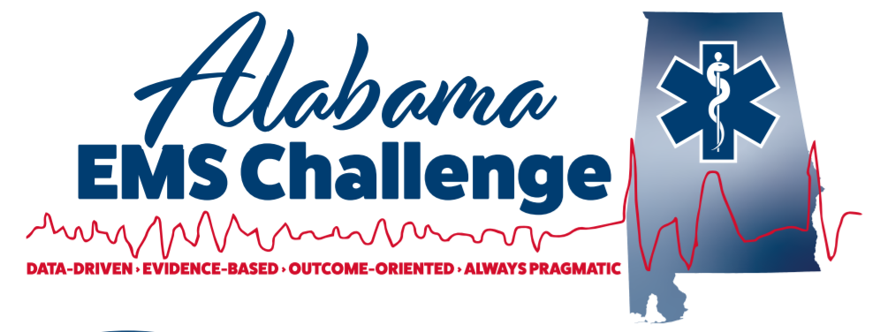
December 14th, 2022, at 9am (0900-1100) at Springville Fire Department 200 Walker Dr, Springville, AL 35146.
Physician-Led Continuing Education for EMS Providers
This is a great opportunity for EMS providers, nurses, students, or anyone interested in emergency medicine.
Come in person or join via MS Teams for the same credit
We now offer Nursing CEU’S too …
9:00-915: Regional Updates – Dr Ferguson
0915-1000- Ventricular Assist Device- Dr. Melissa Willett-Caldwell
1015-11:15— Congestive Heart Failure- Dr. Melissa Willett-Caldwell
^{Lunch Provided}
1230-1430: Skills lab with AEMSC Staff: Pit Crew CPR, Advanced Airway, Surgical Airways, The Basics of Ultrasounds, and selected Mega Code scenarios with the docs!!!

Don’t Miss Out !
Please contact Dr. Will Ferguson (willfergusonmd@gmail.com) or Wes Ward (wward@centerpointfire.com) with any questions or concerns.
Follow on Facebook @ Alabama EMS Challenge/Twitter @EMSdocFerg
Check us out on YouTube here.
December 14th at Springville:
https://teams.microsoft.com/l/meetup-join/19%3ameeting_M2ExOWIxMDctYzU1MS00NTk2LTgxOWYtMGM1MTMyMTZhM2Vm%40thread.v2/0?context=%7B%22Tid%22%3A%22eef12639-b2ba-4510-985a-6b9ef747076c%22%2C%22Oid%22%3A%22e89d7645-1eb7-4b53-b4d0-8095919ef19c%22%2C%22IsBroadcastMeeting%22%3Atrue%2C%22role%22%3A%22a%22%7D&btype=a&role=a

