EAST ALABAMA EMERGENCY MEDICAL SERVICES
LICENSED EMS PROVIDER
QUALITY PLAN TEMPLATE

Region 2, East Alabama EMS, officially recognized by the Alabama Department of Public Health as the Regional EMS office, has actively collaborated with numerous EMS providers to develop a comprehensive preliminary quality plan/template. The Alabama Department of Public Health, working in conjunction with its EMS division, mandates that all licensed EMS providers must submit and rigorously maintain a high-standard quality plan, ensuring its absolute integrity and steadfast implementation, starting in 2024.

The primary focus of this plan template is to offer standardized principles for continuous quality improvement, serving as a guide for the creation of distinctive individual EMS provider plans.

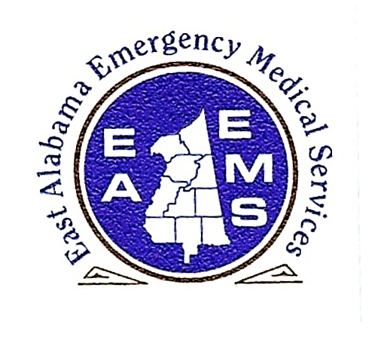

FEBRUARY 2024

Calhoun – Chambers – Cherokee – Clay – Cleburne – Coosa – Etowah – Randolph – Talladega – Tallapoosa

Table of Contents

Foreword: Statement of Commitment to Quality Patient Care…..……………………………………………………..i
Mission, Vision and Objectives………………………………………………………………………………………………………….1
East Alabama EMS Quality Assurance FY2023-FY2024 Priorities……………………………………………………………………………………………..…………………………………………2-3
Emergency Medical Services Quality Plan Key Components………………………………………………………………4
Quality Plan Wheel…………………….……………………………………………………………………………………………………..5
Continuous Quality Improvement…………………………………………………………………………………………………………………………………6-7
Patient-Centered Care……………………………………………………………………………………………………………………8-9
Collaboration…………………………………………………………………………………………………………………………………..10
Organizational Improvement……………………………………………………………………………………………………………………………………11
Accountability…………………………………………………………………………………………………………………………..…12-13
Professional Development…………………………………………………………………………………………………………..14-15
Appendices Table of Contents….……………………………………………………………………………………………………………………………………….16
Appendices………………………………………………………………………………………………………………………………………….

STATEMENT OF COMMITMENT TO QUALITY PATIENT CARE

At East Alabama Emergency Medical Services, our unwavering commitment to quality patient care is the cornerstone of our mission, vision, and values. Every member of our team is dedicated to putting the patient first, recognizing that each individual is not just a metric, but a unique person with distinct needs, hopes, and dreams.

Our mission is to provide a continuum of care that extends beyond medical treatment. It is our belief that true healing encompasses not only the restoration of health but also the preservation of dignity, respect, and compassion. We pledge to uphold this mission in every interaction, at every level of our organization.

Our vision is a healthcare system where patients are at the center of every decision and action. We envision a future where quality is not merely a measure of clinical outcomes but a reflection of the holistic well-being of our patients. This vision propels us to continually seek innovative solutions and embrace best practices to enhance patient experiences and outcomes.

Our values are deeply rooted in the principles of empathy, integrity, and excellence. We understand that every patient entrusts us with their well-being, and we accept this responsibility with the utmost integrity. We are committed to providing excellence in care through ongoing education, research, and the relentless pursuit of the highest standards.

As part of our commitment, we measure success not only by clinical metrics but also by the impact we have on the lives of those we serve. We pledge to listen, learn, and adapt to the evolving needs of our patients. We recognize that quality care extends beyond the walls of our facilities, into the hearts and homes of those we touch.

In summary, at East Alabama Emergency Medical Services, our commitment to quality patient care is a solemn promise to uphold the principles of patient-centered healthcare. We aspire to be an organization where every patient feels seen, heard, and valued, and where the quality of care reflects our dedication to the complete well-being of the individuals and communities we serve.

With unwavering dedication, we remain steadfast in our mission to put the patient first, embracing every opportunity to make a positive difference in the lives of those we care for. This commitment is the heartbeat of our organization, and we pledge to carry it forward with compassion, empathy, and excellence, today and every day.

Written by John E Blue, II its CEO on this 11th day of September 2023 honoring those colleagues who have fallen.

