Dr. Crawford EMS 10th Edition Presentation Bullet Points (February 1, 2022)
- The Alabama Protocols 10th Edition has a new format
- The 9.01 Edition’s Format
- 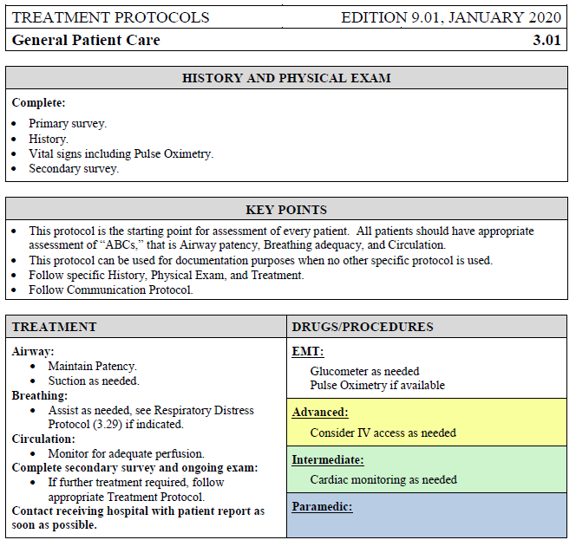

- The 10th Edition Format (New Format)
- 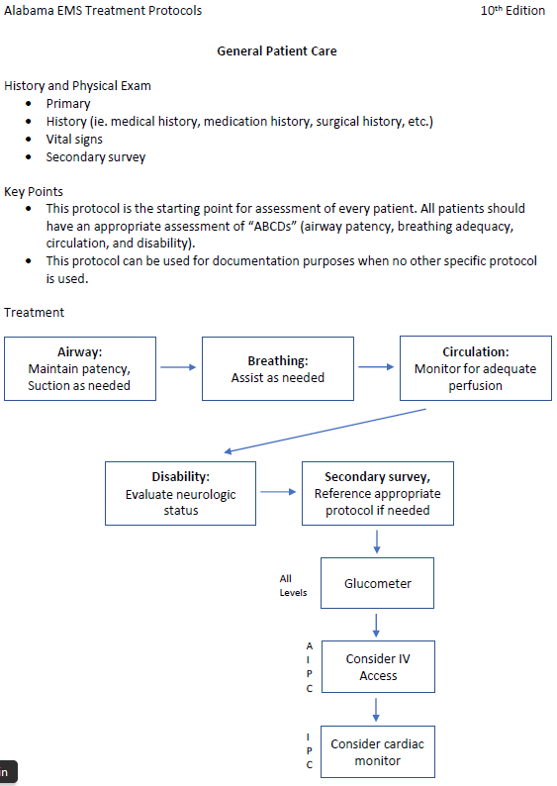
- algorithm type
- See protocol document
- Left of treatment boxes are letters (ie AIPC, IPC, all levels)
  - Defines who can perform given treatment
  - A-Advanced; I-Intermediate; P-Paramedic; C-Critical Care Medic

- Category A
- Do not need to call for orders
  - Except for pediatric intubation (less than age 3)

- Adult tachycardia
- “Consider OLMD Consultation” - Gives the opportunity to call medical control, but You do not need too
- 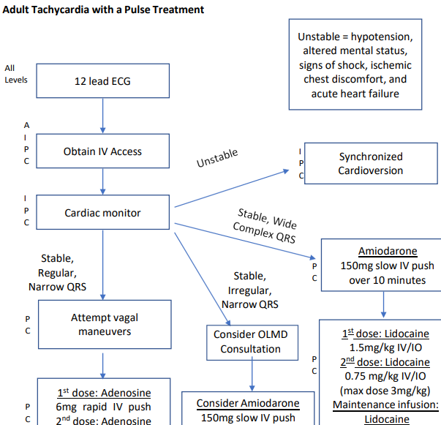

- NEW MEDICATIONS:
- Tylenol- added for mild pain (Page 97)
  - 1 g for adult
  - 15 mg per kilogram up to 1000 mg for children
  - Not for liver disease
- Albuterol- all levels can give (Page 97)
  - Asthma & COPD
  - Missed dose
- Epinephrine (Page 103)
  - 1:10,000 for cardiac arrest (pediatric and adult)
  - Advanced and intermediate
- Solu-Medrol (Methylprednisolone) (Page 109)
  - Pause for hyperglycemia
  - For all advanced, intermediate, and paramedic
  - Missed dose
- Midazolam (Versed) (Page 110)
  - Added to advanced and intermediate for seizures only
  - Nasal only
  - Missed dose
  - Some side effects
    - Apnea
    - Hypertension
    - Dysrhythmia
- Rocephin and Ancef (Page 100, 101)
  - All 3 levels
  - 2 indications
    - Sepsis
    - Open fracture
  - Call med control if You have a question about their allergies and whether You can give them
- Toradol (Brand Name) (Page 117)
  - NSAID
  - IV Form
  - Added to all 3 levels
  - Moderate pain
  - Trying to get away from ketamine
    - Not great for pain control
  - Kidney stones, etc.
  - Contraindications
    - Older aged
    - Renal insufficiency- dialysis
    - Stroke/traumatic brain injury within last 24 hours
    - If already had NSAID within 8 hours
- TXA (Tranexamic Acid) (Page 118)
  - Bleeding/trauma patients
  - Older than 15 y/o
  - Less than 3 hours from injury onset

- PROTOCOLS:

- Adrenal Insufficiency (Page 22)
  - All can give Solu-Medrol
  - 125 mg IM or IV in adult
  - 2 mg per kilogram IM or IV for pediatric, 125 mg max
  - Any of the three suggested meds can be used
    - Solu-medrol is encouraged
    - 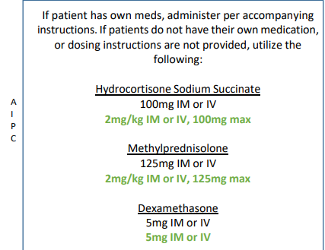
- Asthma and COPD (Page 28)
  - Added albuterol for EMT level
  - Solu-Medrol
  - Consider CPAP or BiPAP for all levels
  - 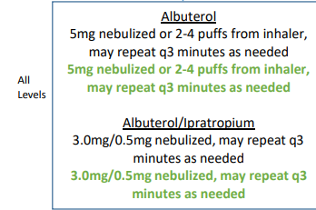
- Cardiac Arrest (Page 32)
  - Epinephrine
  - 1:10,000 but must be in cardiac arrest
  - 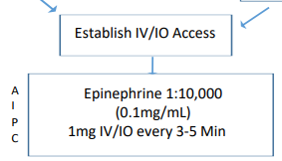
- Congestive Heart Failure (Page 45)
  - No new treatments
  - Check for signs
  - Reduce preload with nitroglycerin
- Croup (Page 47)
  - Racemic epinephrine for AIPC
  - 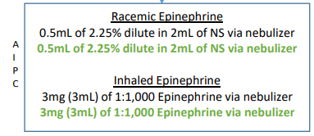
- Hypothermic (Page 60)
  - IV fluids if in shock or dehydrated
- Hypoglycemia (Page 58)
  - Give oral glucose
  - D10
    - Preferred
    - Readily available
    - More stable
    - 250 mL IV in adult
      - Maybe follow up with 30cc/hr
    - 4 mL per kg in pediatric, 250 mL max
    - Still can use D50, D25, D5 etc.
    - D10 preferred
- Pain Management (Page 70)
  - Mild pain Tylenol
    - 1000 mg adults
    - 15 mg per kg pediatric
  - Toradol for greater than 1 y/o
  - Ketamine for refractory pain
  - Morphine/Fentanyl doses in protocol
    - Use before ketamine
- Seizures (Page 78)
  - Intranasal Versed
  - Pediatric short-lived seizures
  - Pregnant may be due to eclampsia
    - See those protocols
- Sepsis (Page 80)
  - Fluids and antibiotics
  - Organ dysfunction caused by infection
  - Lactate greater than 4 or hypotensive, 30mL per kg
    - Tell Nurse how much fluid you have given
  - Antibiotics
    - Rocephin
  - May need to add pressor- (dopamine or epi infusion)
  - Epinephrine push dose
    - 1:10,000
- General Trauma (Page 91)
  - TXA
    - Vaginal bleeding
  - Open fracture
    - Antibiotic
    - Rocephin
    - Ancef
- Stroke (Page 84)
  - EMSA scale
  - TCC will ask about EMSA starting April 1st
  - Training will come out soon
  - TCC can talk through it if unfamiliar
  - Used to identify large vessel occlusion
  - Mechanical thrombectomy capable hospitals

- Don’t hesitate to call medical control. They are there to help you.

- Will go live on the last Friday of April (April 29th)

- Once the Protocol training is complete, send a notice of completion to Allan Pace (allan.pace@eastalabamaems.com ) with date(s) of completion and your services off-line medical director. A certificate will be generated with the Regional Course approval number on it for you to use to finish certificates for your staff.

