AMTRAK Passenger Train Emergency Response Training June 10

Free 4-hour railroad safety course at the Calhoun County EMA
View this email in your browser

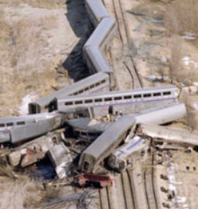
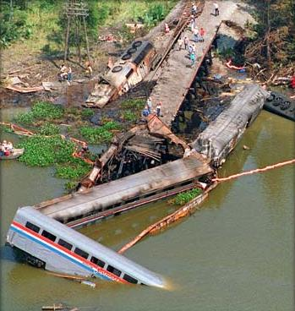

AMTRAK Passenger Train Emergency Response Training

June 10 from 8 a.m. - Noon at Calhoun County EMA
Who should attend:
- First Responders (Fire, Law, EMS)
- Emergency Management
- Public Health
- Coroners
- Dispatchers
Topics will include:
- Railroad right of way dangers and safety concerns
- Passenger and freight railroad relationship
- Mainline switches are remotely controlled
- Frequency of trains, including maps and schedules
- Access points to the railroad
- Challenges of extraction
- Environmental issues
- And, more!
To register, please email Ashley Siskey, asiskey@calhounema.org.
Agencies interested in hosting the class for their personnel only may also contact Ashley Siskey for details.

Copyright © 2015 Calhoun County EMA, All rights reserved.
Our mailing address is:
507 Francis Street W
Jacksonville, AL 36265
unsubscribe from this list update subscription preferences

