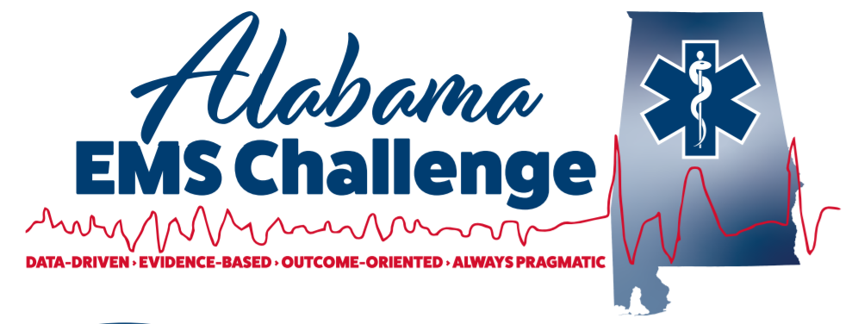June 23rd, 2021 at 9am (0900-1100) at the Mobile Convention Center Rooms 201 C & D at 1 S Water St., Mobile, AL 36602
Hosted by Mobile Fire Department
Physician-Led Continuing Education
Limited in person due to COVID but still Online and Same credit on-line as if you were there !!
We now offer Nursing CEU’S too …
To join via MS Teams at 9:00 AM on June 23rd click here.
June 23: 9:00 AM- 11:00 AM Lecture
11:00 AM- 12:30 PM LUNCH on site
^{12:30 PM- 2:30 PM SKILLS Lab}
Lectures:
Dr. Will Ferguson ---Select cases with 12-Lead ECG Review
Dr. Jason Eversull---Non-ACS Chest Pain
Skills Lab: (in-person only)
Pit Crew CPR---Scenarios with the Docs---Difficult Airway Techniques
Do not Miss out !
Please contact Dr. Will Ferguson for any questions or concerns at willfergusonmd@gmail.com
Follow on Facebook @ Alabama EMS Challenge/Twitter @EMSdocFerg
Unmasked link:
https://teams.microsoft.com/l/meetup-join/19%3ameeting_N2UwYTAyNzgtM2U2OS00YjMyLWI3NjEtZWUyODJmMjMwY2Ux%40thread.v2/0?context=%7b%22Tid%22%3a%22ad19903c-a5f1-409f-8da3-ef35a7ac9238%22%2c%22Oid%22%3a%2222af8552-b9be-42b9-8d05-dff6e745238b%22%2c%22IsBroadcastMeeting%22%3atrue%7d

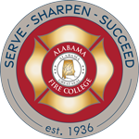
Alabama EMS Challenge is proudly sponsored by the Alabama Fire College

Train Like Somebody’s Life Depends on It!
Non Sibi Sed Suis

