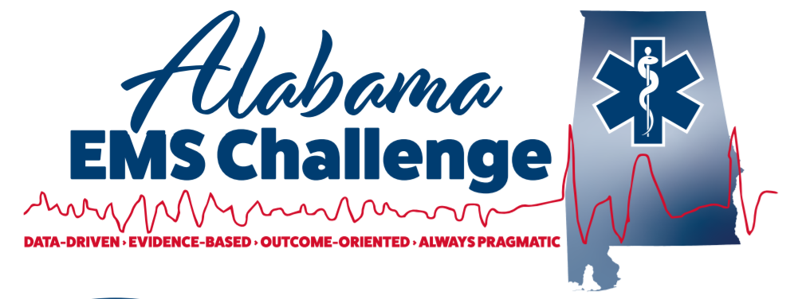
July 20th, 2022, at 9am (0900-1100) at Troy University hosted by the Troy Fire Department. The address for the event will be Hawkins Hall, 547 University Ave., Troy AL 36082
Physician-Led Continuing Education for EMS Providers
This is a fantastic opportunity for EMS providers, nurses, students, or anyone interested in emergency medicine.
Come in person or join via MS Teams for the same credit
We now offer Nursing CEU’S too …
9:00: 12 leads / Tachycardias and ACS- Dr. Ferguson
10:00: Chest and Abdominal Trauma – Dr. Ferguson
11:00-12:30 Lunch provided
12:30-2:30: Skills Lab with the docs
Dr. Willet and Dr. Davidson / UAB EMS Fellows
Advanced airway / surgical airways/ US/ Mega Code training
Don’t Miss Out!
Please contact Dr. Will Ferguson (willfergusonmd@gmail.com) or Wes Ward (wward@centerpointfire.com) with any questions or concerns.
Follow on Facebook @ Alabama EMS Challenge/Twitter @EMSdocFerg
Check us out on YouTube here.
The MS Teams link for the event will be:
https://teams.microsoft.com/l/meetup-join/19%3ameeting_NWI0MjlmM2UtOGExYS00MTUyLTk1YmYtM2RjMzQ1NDhiZTFm%40thread.v2/0?context=%7b%22Tid%22%3a%22ad19903c-a5f1-409f-8da3-ef35a7ac9238%22%2c%22Oid%22%3a%2222af8552-b9be-42b9-8d05-dff6e745238b%22%2c%22IsBroadcastMeeting%22%3atrue%7d&btype=a&role=a

