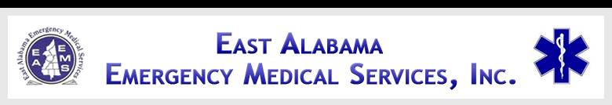

EAST ALABAMA EMS
Presents
Mental Health Patients
At our 2ND FRIDAY LECTURE SERIES
FRIDAY, May 10, 2013
10:30 AM – 2:30 PM
East Alabama EMS Office
58 Speedway Industrial Drive
Lincoln, AL 35096

Sponsored by
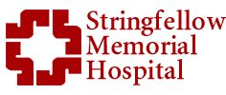

OBJECTIVES
- Understanding the impact of treatment and bed reduction
- How to safely and effectively interact with the mentally ill in crisis
- Explore opportunities for improving treatment and responses
- Understand the roles of
pre-hospital and in-hospital providers.
AGENDA

1030-1035 Introductions
1035-1100 Mental health review
1100-1120 Least restricted environment
1120-1135 Treatment bed reduction
1135-1200 Impact on first responders
1200-1230 Lunch will be served
1230-1320 Mental health diagnosis
1320-1425 How to engage with the mentally ill
1425-1430 Evaluations

SPEAKER INFORMATION

Jon Garlick, Ed.S. MS, LPC, NCC

Sergeant Garlick has been with the Calhoun County Sheriff’s Office since 2002 and serves as Mental Health Officer, Crisis Intervention Specialist, and also counselor for youth and adult clients through DHR, among other duties.
There is no charge for attendance but pre-registration is strongly encouraged. 4.0 contact hours will be awarded to those who complete this program. No partial credit will be awarded. You must attend the course in its entirety to receive credit. EAEMS will be providing continuing education credits to EMT’s and nursing contact hours to nurses. East Alabama EMS is an approved provider of continuing education for nurses by the Alabama Board of Nursing. Provider Number _ABNP 1456__ expires: _08.25.2015_. Nurses must bring their current Alabama Board of Nursing license to the program to be swiped in order to receive contact hours.
TO REGISTER OR FOR MORE INFORMATION:
Contact East Alabama EMS 205.763.8400 or eaems@centurytel.net

